Course (from Linkedin Learning):- Python For Data Science Essential Training Part – 1

Module – 3 Data Visualization 101

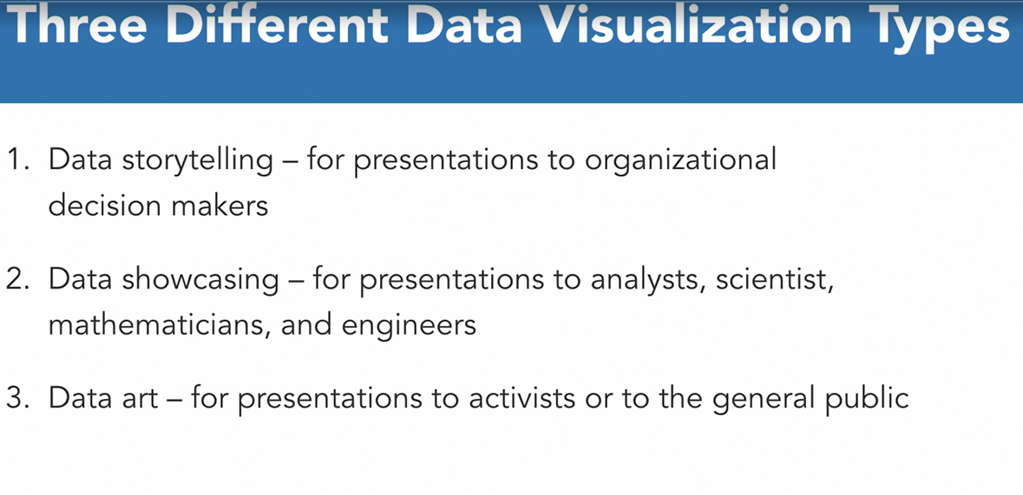

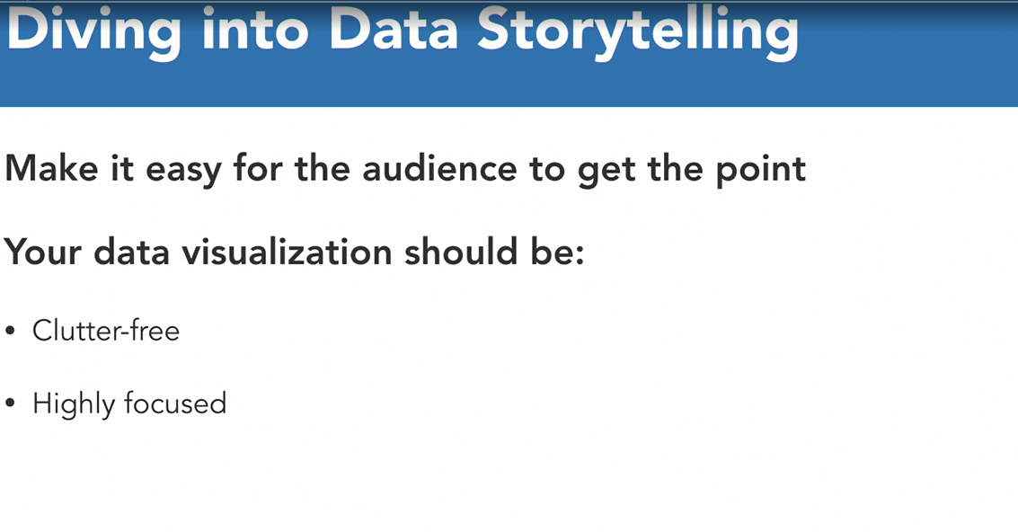

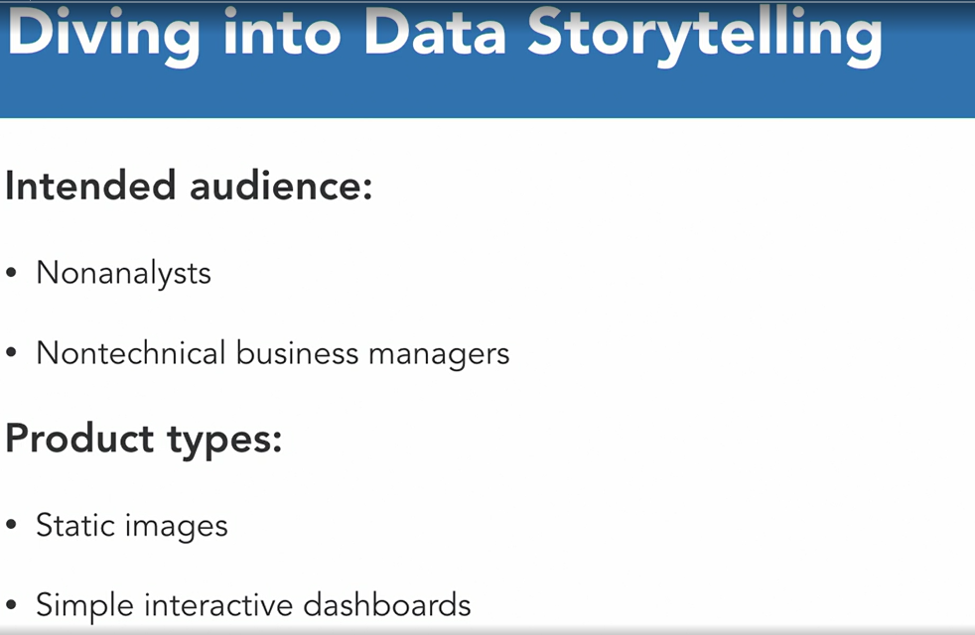

Example of Data StoryTelling

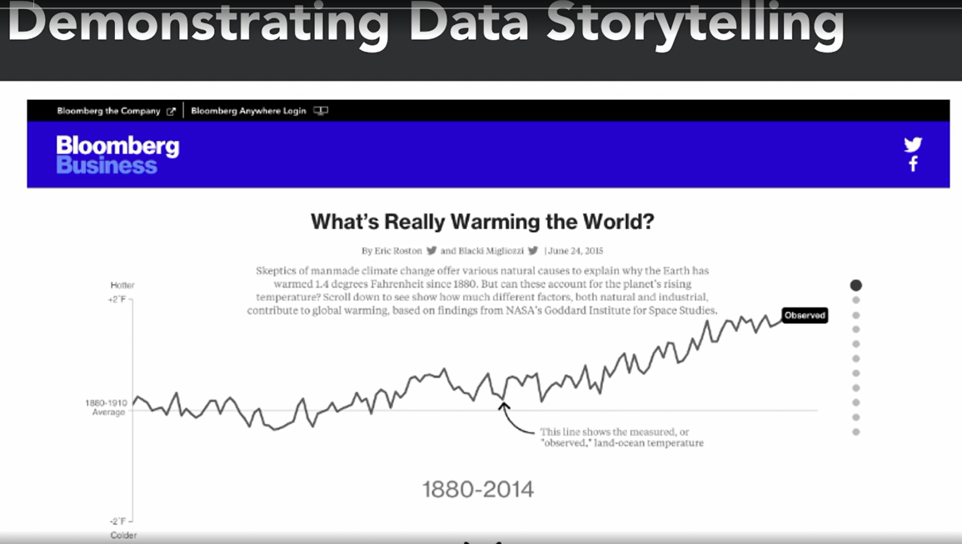

2) Data ShowCasing :-

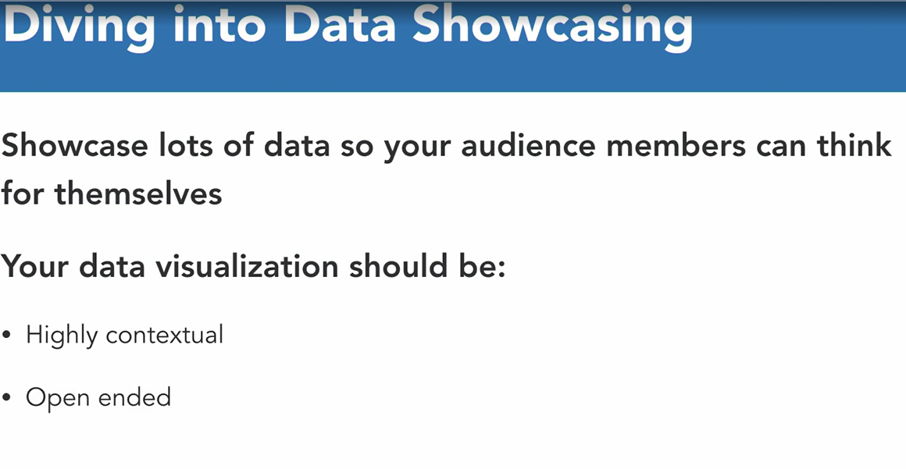

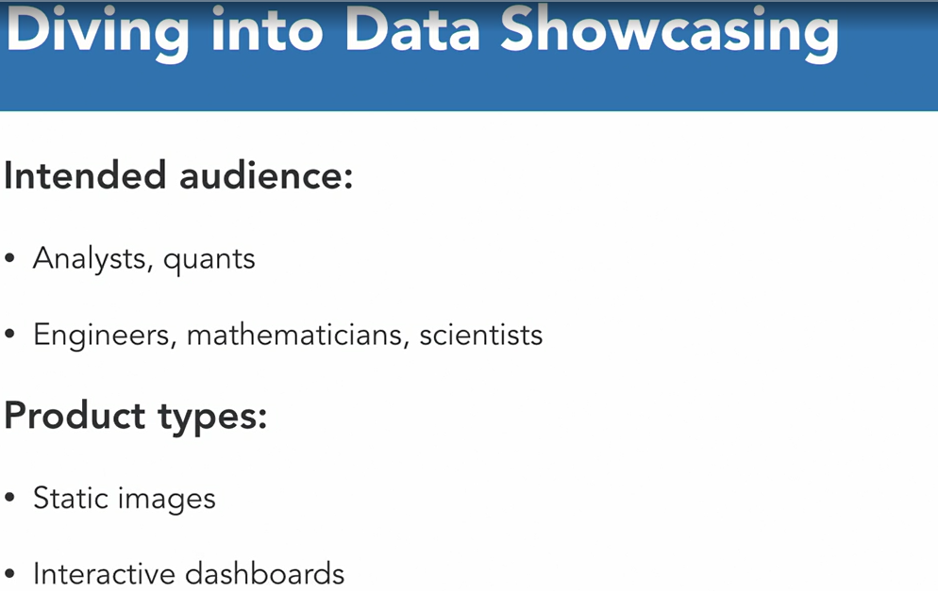

Example of Data Showcasing

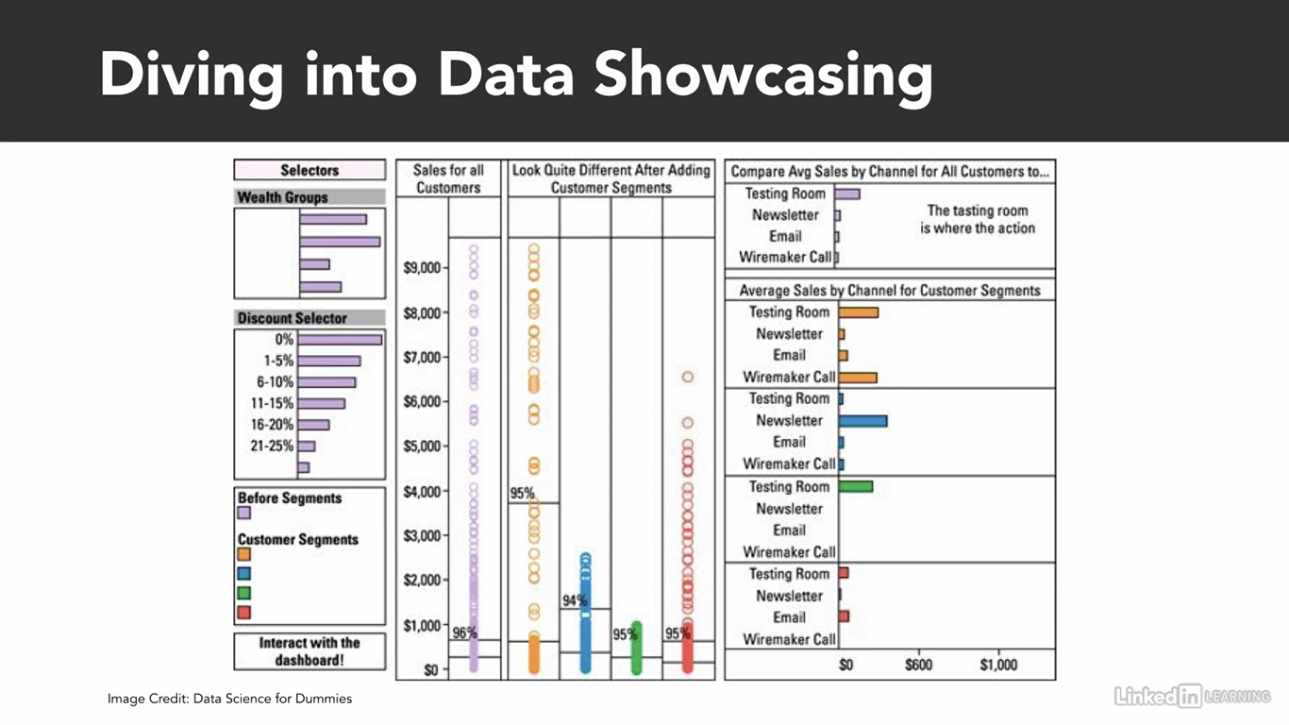

3) Data Art :-

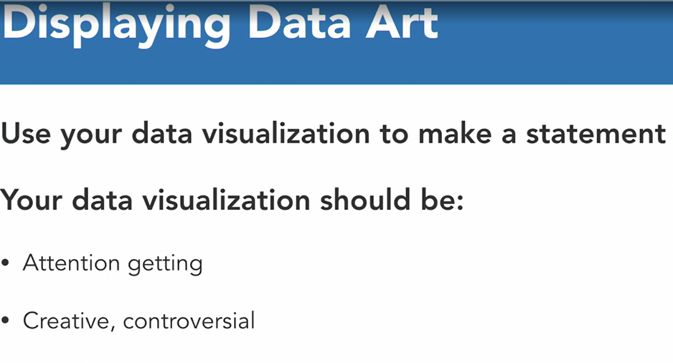

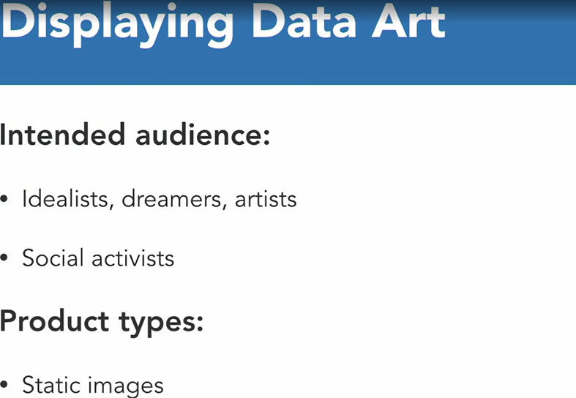

Example of Data Art :-



Now Select Optimal Data Graphic Tool :-

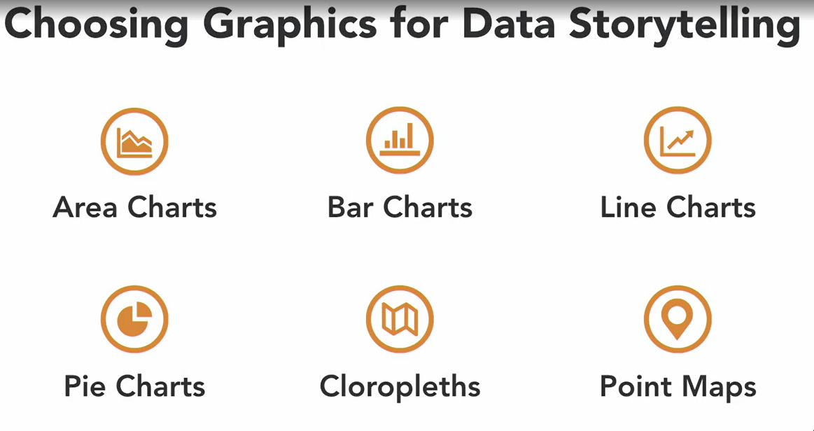

Example of Choropleths:-

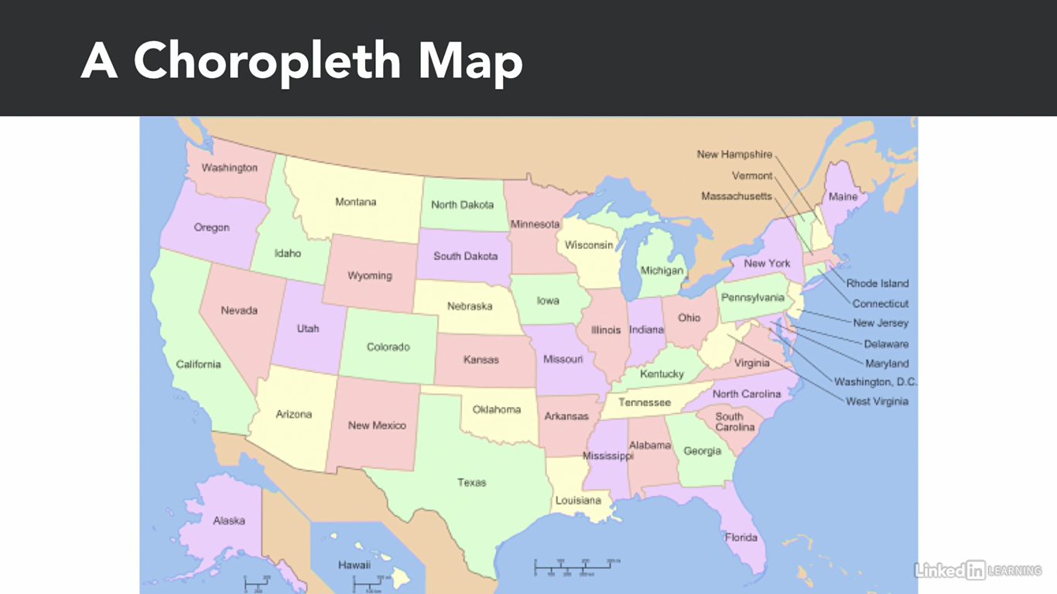

Example of Point Map :-

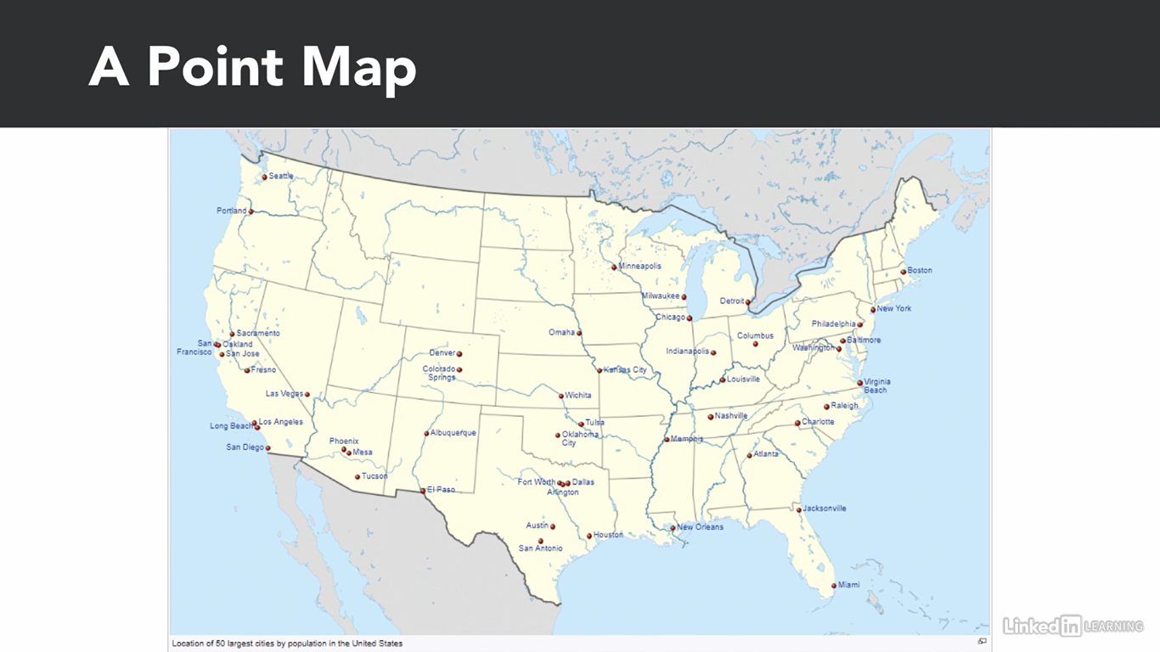

Choosing Graphics for Data Showcasing :-

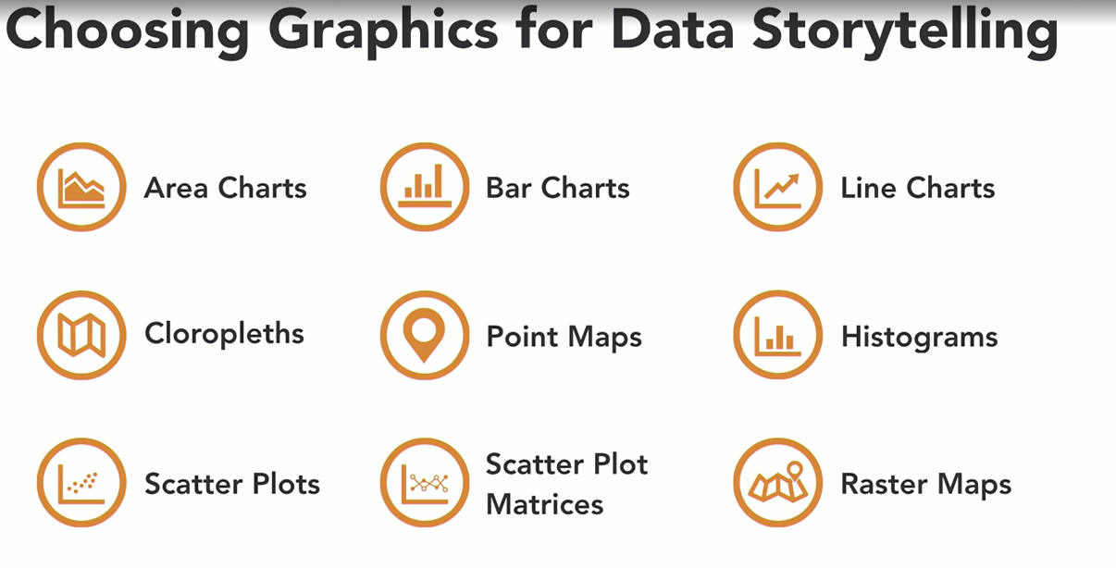

Example of Raster Maps :-

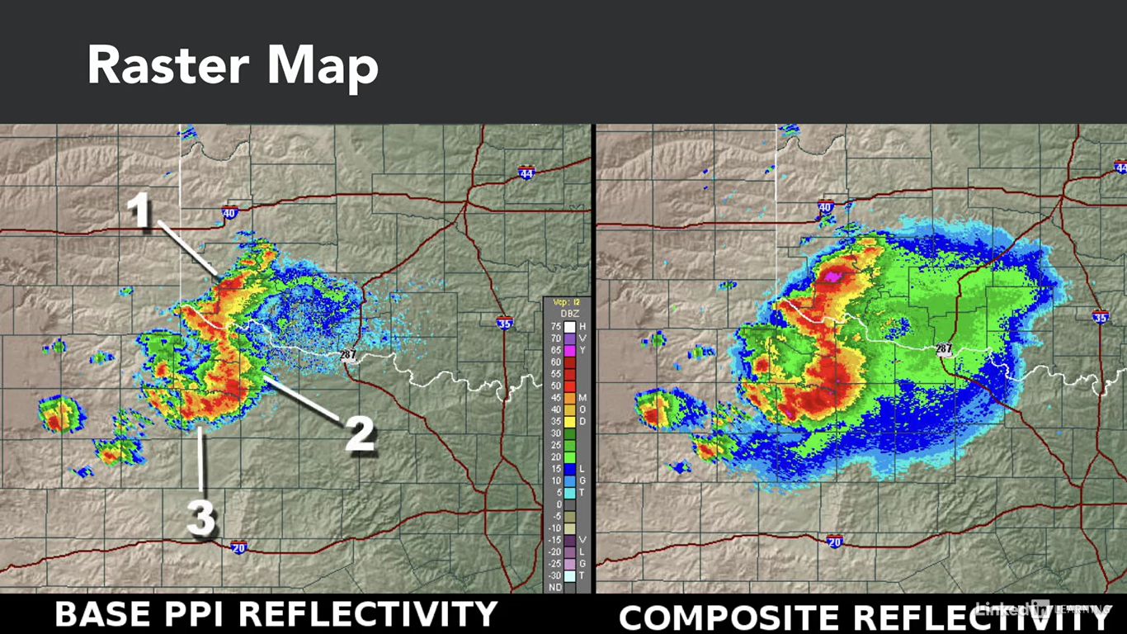

Choosing Graphics for Data Art :-

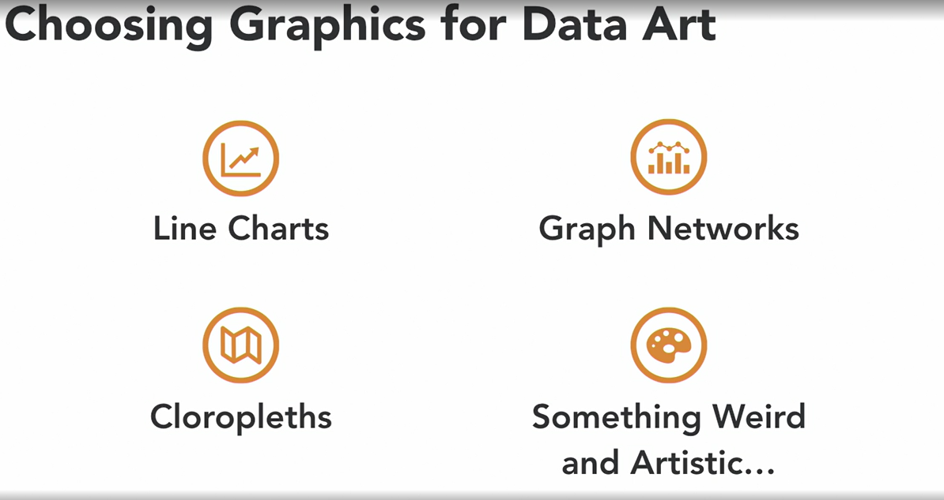

Example :-

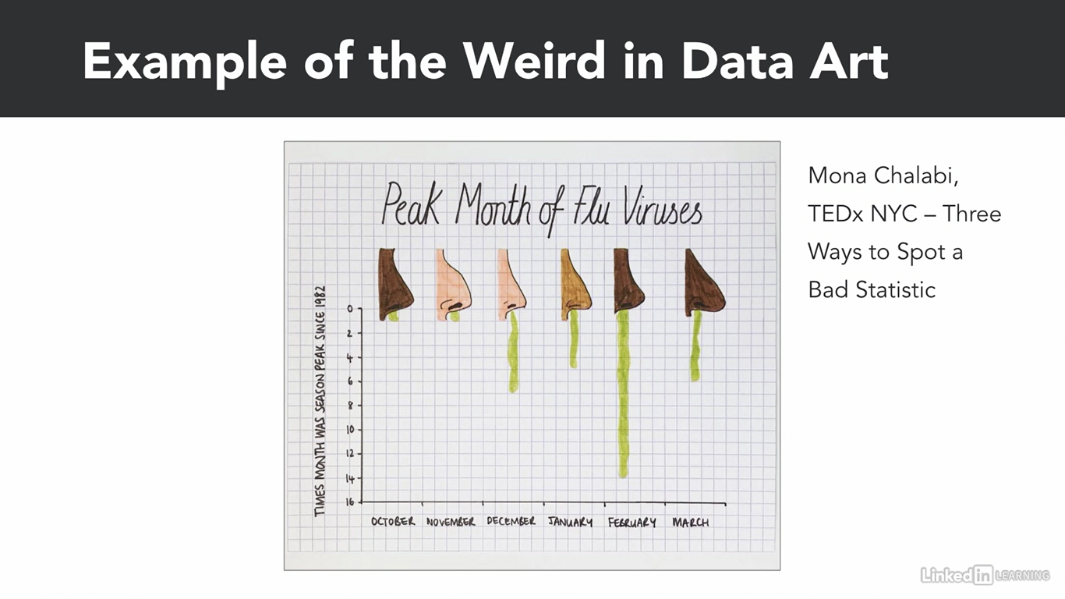

4 Steps to choose right graphic tool. Or how to decide right graphic tool for data visualization :-

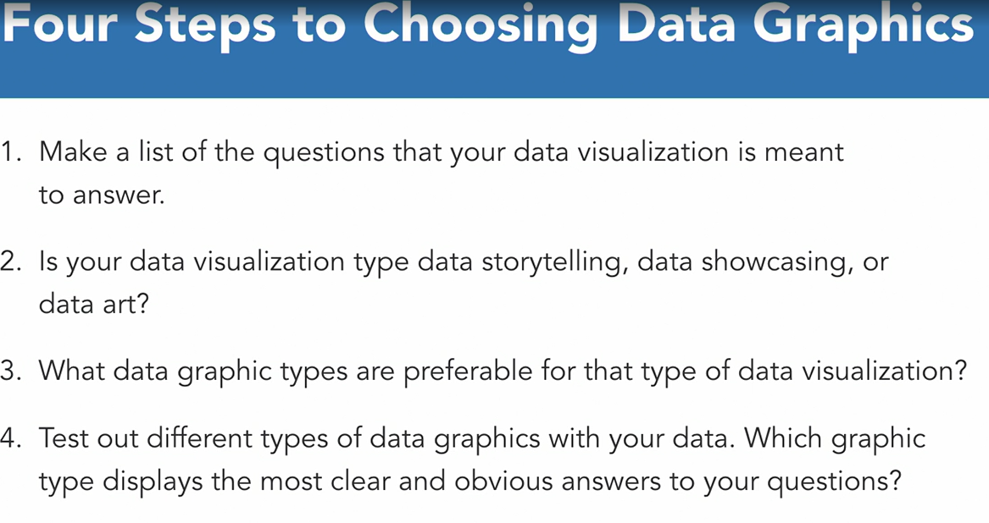

4th Step continues:-

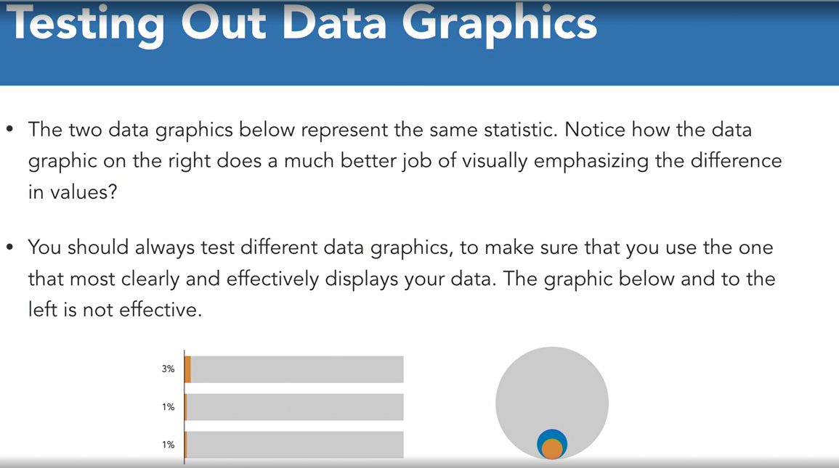

Lecture – 3 :- Communicatin with color and context

This is remaining. Pls add SS in your free time.

Module – 4 :- Practical data visualization :-

So char representation is most common and generic and useful way to represent or visualize data. So let’s learn how to visualize data in terms of charts first (line charts, bar charts, pie charts).

Pls include SS here.

So there are mainly 2 ways to visualize data.

Functional way :- it means we are applying functions and method on some variable or dataset or subset of data set to plot or visualization.

Object – Oriented Way :- In Object Oriented way, first empty object will be created and in that object afterwords variable or data elements and it’s corresponding graph elements will be added.

Pls include SS.

\*\***Functional way :-**

Let’s create standard data graphics using Matplotlib and Seaborne.

Creating line chart from a list object. :-

So first we need to have object for 2 axis in chart.

X = range(1,10) # will generate list of numbers from 1 to 9.

Y = [1,2,3,4,0,4,3,2,1]

Now to generate a line chart, what w need is plot function. And pass both this object into it as an argument for x and y axis.

Plt.plot(x,y)

Now creating a Line chart from a Pandas Object :-

Mpg_data = cars[‘mpg’]

Mpg_data.plot()

Now let’s generate a line chart which is plotting 3 variables on graph.

So for that first of all, we need to create dataframe.

Df_data = cars[[ ‘cyl’ , ‘wt’ , ‘mpg’ ]]

Df_data.plot()

**Creating Bar Charts :-**

Creating Bar chart from a list object:-

So to generate bar chart, we are having bar function.

Plt.bar(x,y)

Creating bar chart from a pandas bject :-

So to generate bar chart from pandas object, we need plot() function nly. Bt with specific argument to generate chart as bar chart.

Mpg_data.plot( kind=’bar’ )

Now u will be able to see bar chart and is layed out vertically on the screen. Bt now what if you want bar chart for same dataset bt in horizontal manner? We only need to append alphabet h after ‘bar’ while passing the argument.

Mpg_data.plot( kind=’barh’)

**Creating Pie Chart :-**

To create pie chart from list we need to have pie function.

X = [1,2,3,4,0.5]

Plt.pie(x) # this will only generate pie chart bt won’t show on the screen.

So to show on the screen in case of pie chart, we need to use show function.

Plt.show() # will show on the screen.

**Saving plot as an image :-**

so let’s see how to save pie chart. To save a pie plot we need to create pie plot and then apply savefig method to save it.

Plt.pie(x)

Plt.savefig( ‘pie_chart.png’ ) # this will save the plot named as argument name. and it will save it in your present working directory. (in jupyter if u want to check your present working directory, then run %pwd command).

**Lecture – 2 :- Defining Elements of a Plot.**

Now let’s learn how to define elements of a plot using matplotlib.

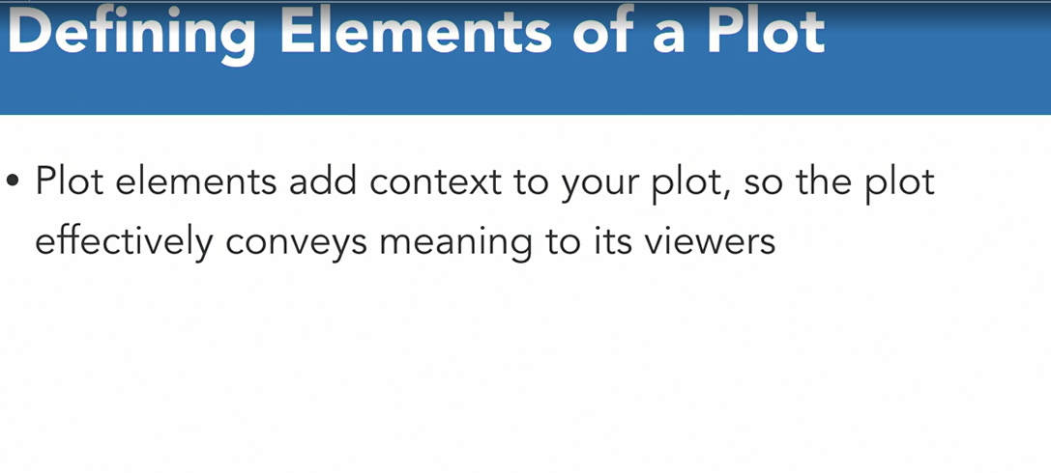

**There are 2 methods to plot.**

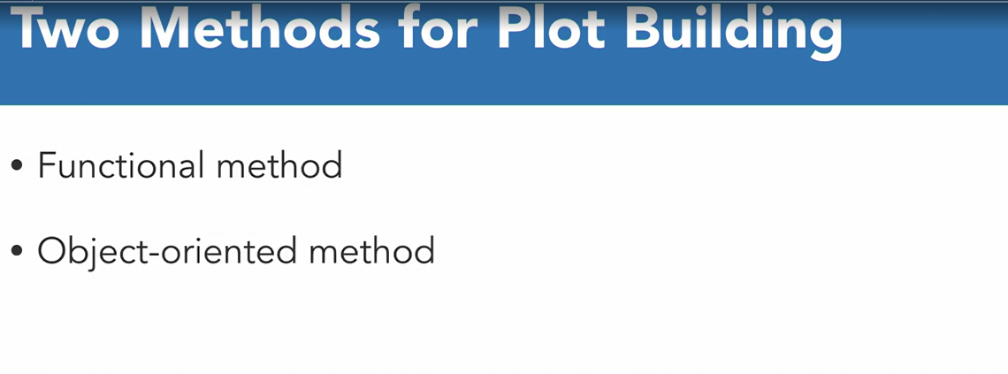

Matplotlib. So previously we have seent how to build plots in funcational way. Now let’s see object oriented way. So as we know in object oriented way, first we need to create blank figure object. And then need to fill it with plot and plot elements to build plot.

Below are the steps to generate the plot using object oriented method.

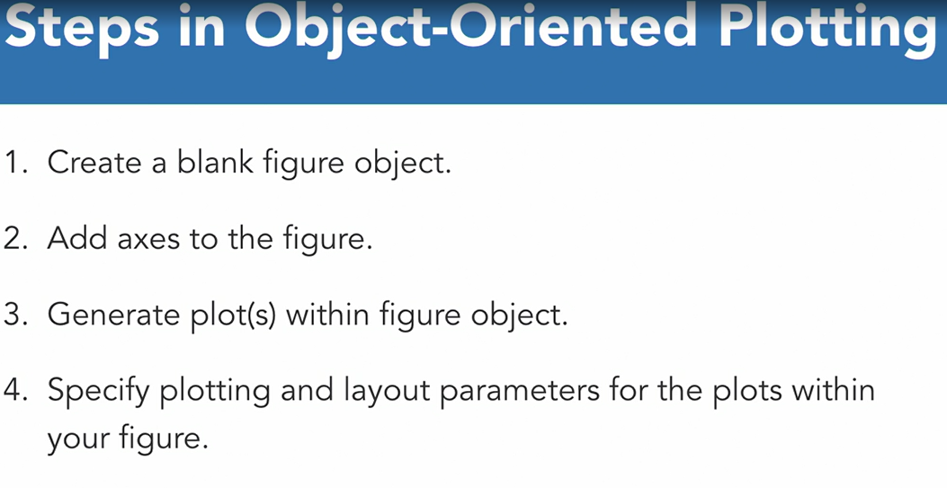

One more important thing in ploting is subplot. And it is very easy to plot subplot using subplots function in matplotlib.

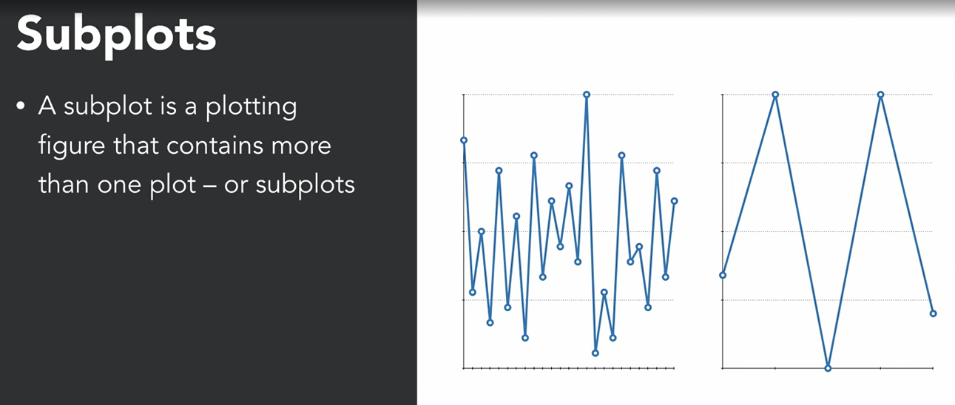

Now finally let’s learn practicall how to generate plot.

Import numpy as np

From numpy.random import randn

Import pandas as pd

From pandas import series,datafreame

Import matplotlib.pyplot as plt

From matplotlib import rcParams

So we have imported all the required libraries and modules and functions from that libraries.

Now first thing we need to do is to set plot in line and with proper figure in the jupyter notebook screen.

%matplotlib in line # this command tells python to plot all the matplotlib plots in line with jupyter notebook screen

rcParams [figure.figsize] = 5,4 # this command tells python to show all the figures 5 inches horizontally and 4 inches verticaly only.

Now let’s define the axes, ticks and grids of the plot.

X = range(1,10)

Y = [ 1,2,3,4,0,4,3,2,1 ]

So our first step is to create blank figure on the screen. So let’s create blank figure

Fig = plt.figure() # will create blank figure

Next step is to add axis on the figure. So we can do it by calling add_axes method on that balnk figure object.

Ax = fig.add_axes([0.1,0.1,1,1]) # this still won’t visible on plot.

To show on graph, use plot method on above object.

Ax.plot(x,y) # this will plot the figure on the screen.

Till this, is the basics of object oriented plotting method. Now let’s deep dive into it.

So let’s add limit and ticks on x axis and y axis.

Fig = plt.figure()

Ax = fig.add_axes([0.1,0.1,1,1])

Ax.set_xlim([1,9]) #pass lower limit and upper limit for x-axes.

Ax.set_ylim([0,5]) #pass lower limit and upper limit for y-axes.

Ax.set_xticks([0,1,2,4,5,6,8,9,10]) #to set ticks on the axes

Ax.set_yticks([0,1,2,3,4,5])

Another thing we can do is to add background grid in the chart.

Ax.grid()

Ax.plot(x,y)

Generating multiple plots in one figure with subplots. :-

Fig = plt.figure()

Fig, (ax1,ax2) = plt.subplots(1,2)

Ax1.plot(x)

Ax2.plot(x,y)

Lecture – 3 :- Plot Formatting :-

Let’s see how to apply custom styles and colors for lines and other plot elements.

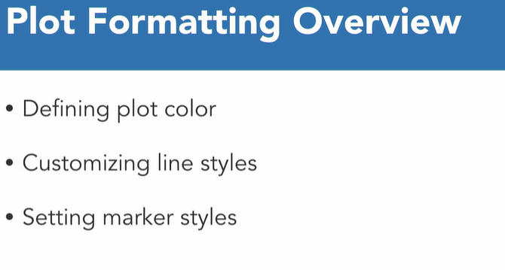

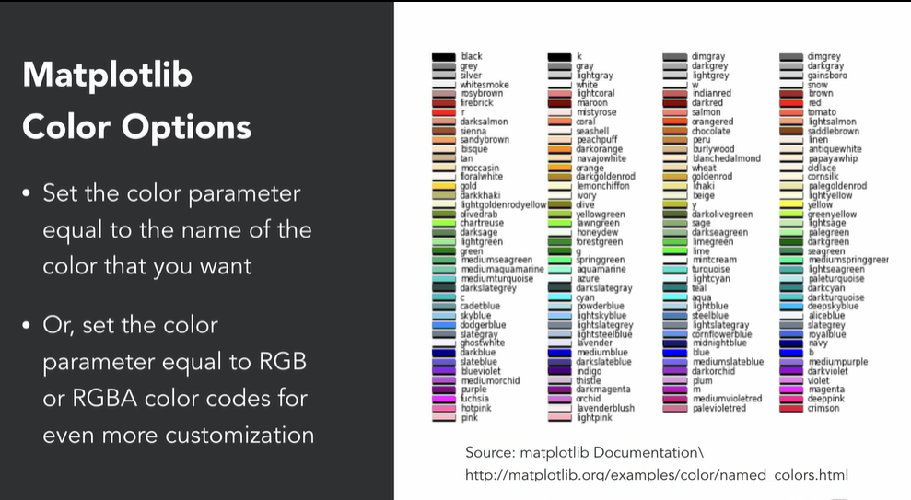

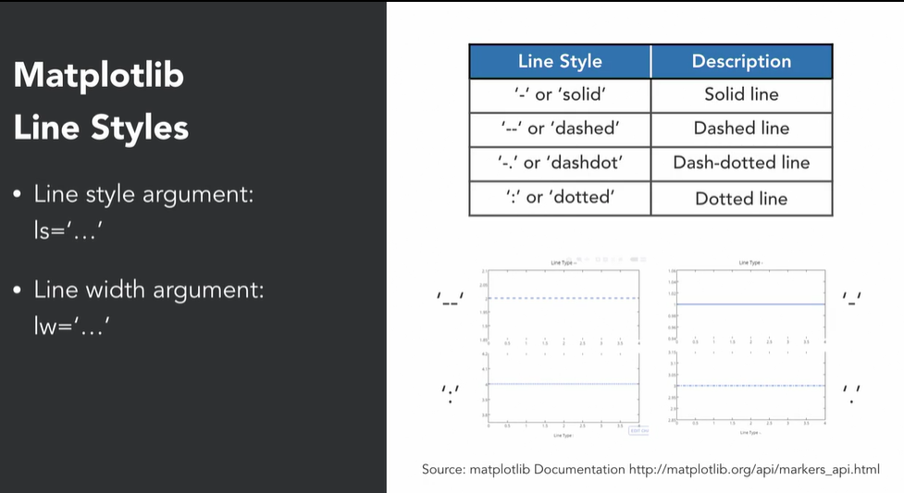

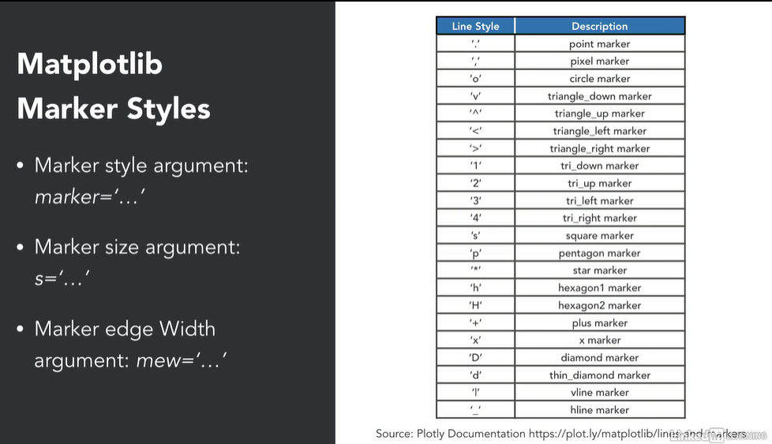

Data Plot Formatting for list objects:-

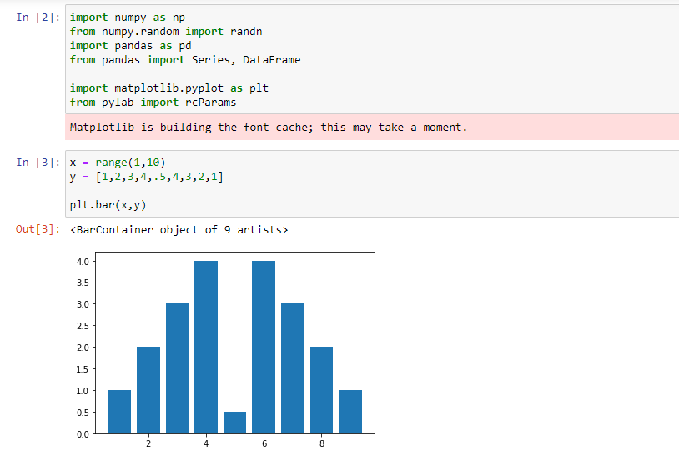

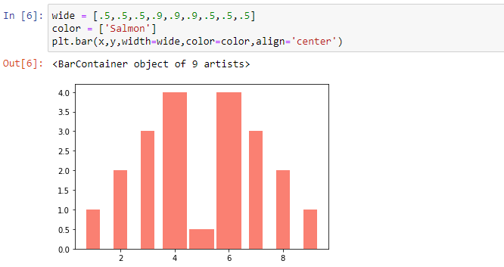

Now let’s do it for pandas object:-

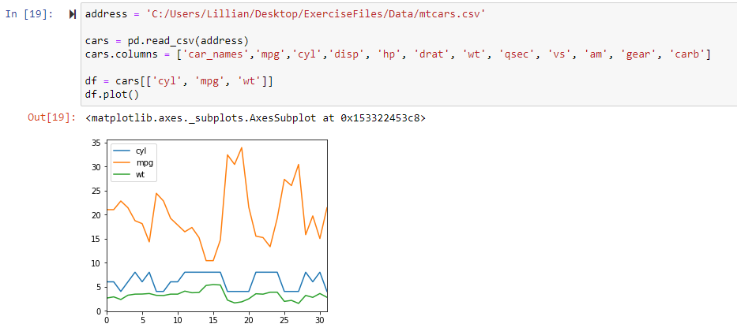

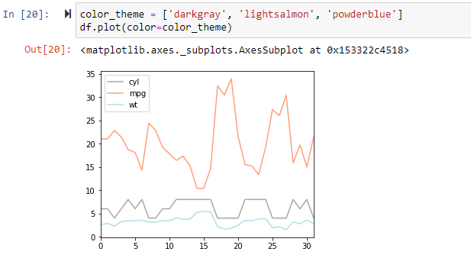

So we have seen how to change plot colors. We can change it through RGB also. So let’s see it.

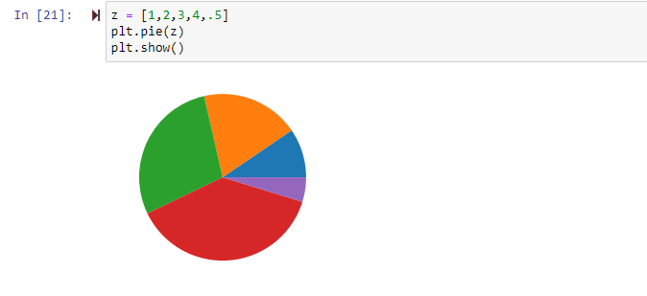

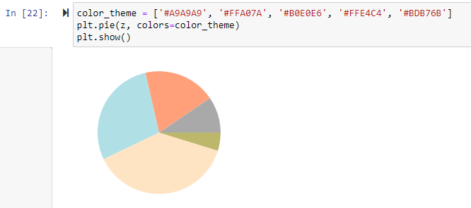

So now let’s see how to draw customize Line style.

For that first we need to create 2 variables as usual. And try to plot it normally.

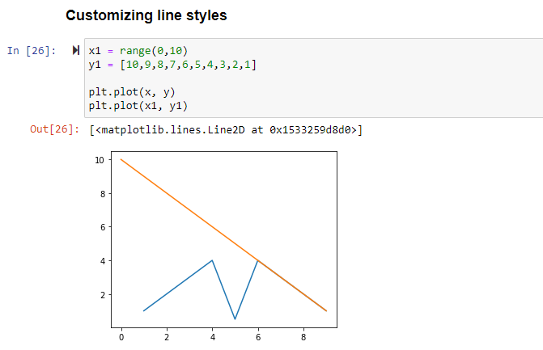

Now let’s change the drwind style of first line as stepping. And also change the line width as well. And for 2nd line also let’s change the line style and width as well.

Note that ds stands for drawing style, ls stands for line style, lw stands for line width.

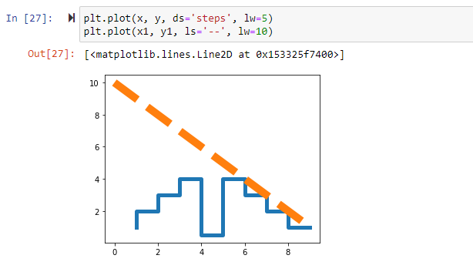

Now let’s see how to set plot markers in chart. Note that mew stands for marker width.

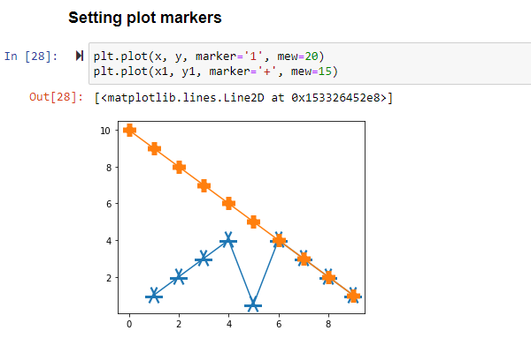

Lecture – 4 :- Creating Labels and Annotations

So let’s see how to create lables and annotations in the plot as it is very important thing to show as it provides more meaningful context to the user.

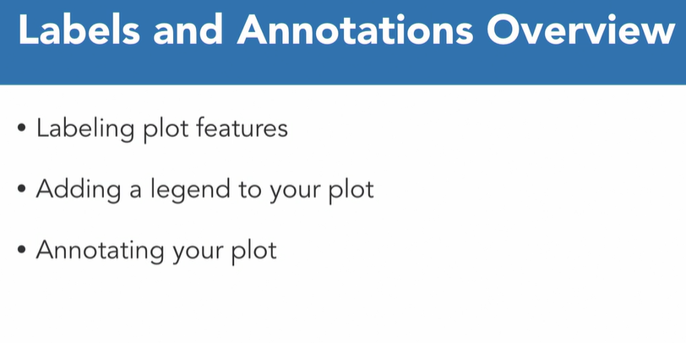

So there are mainly 2 methods to include lables and annotations.

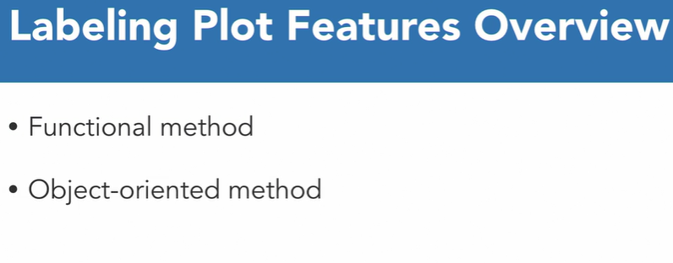

In order to add legend in the char, we need to use legend method.

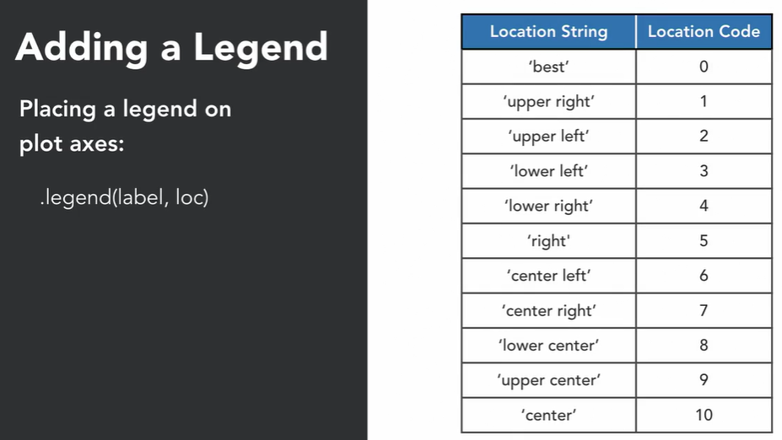

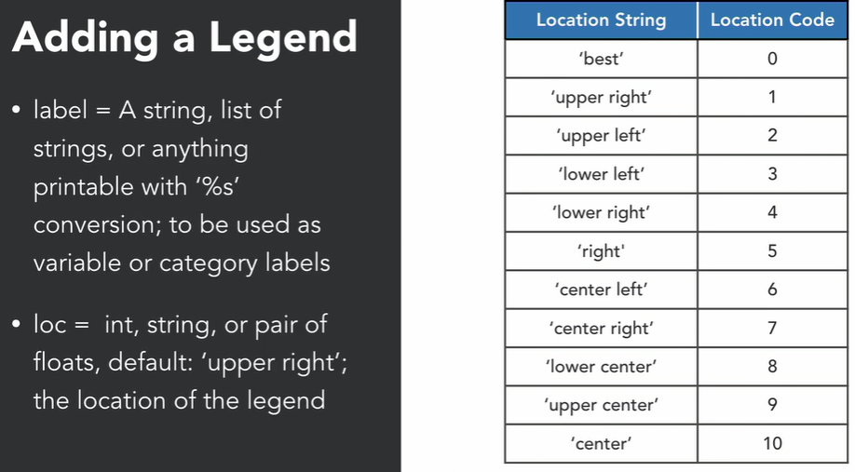

In order to add Annotation, we need to use the annotate method in which accepts the arguments like the annotation location, annotation text, and it’s location and drawing style.

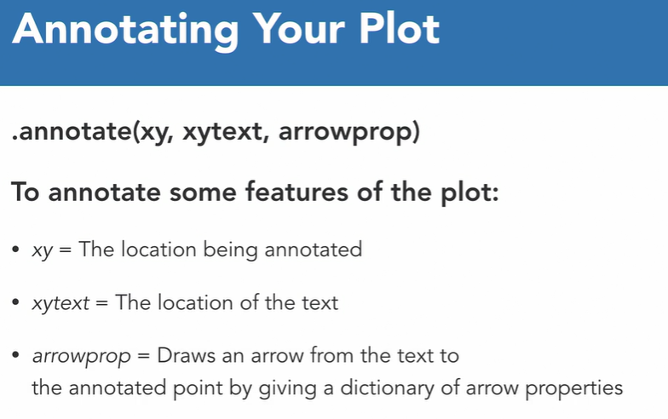

Now let’s look practically using Functional method to create lables and annotations.

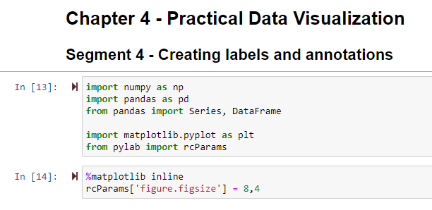

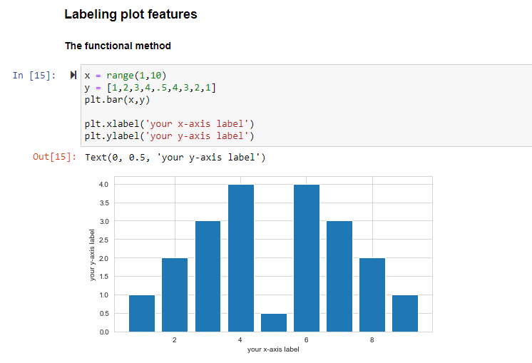

Now let’s see how to label in pie chart.

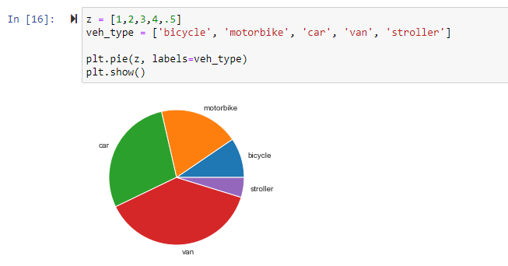

Now let’s add the lables using another method (Object oriented Method ). As we know in orject oriented method, first we need to create empty figure and then start putting objects like axes, plots, lables etc as per the requirements.

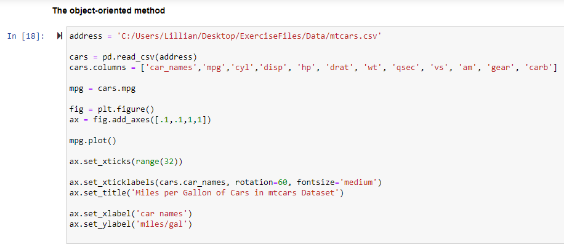

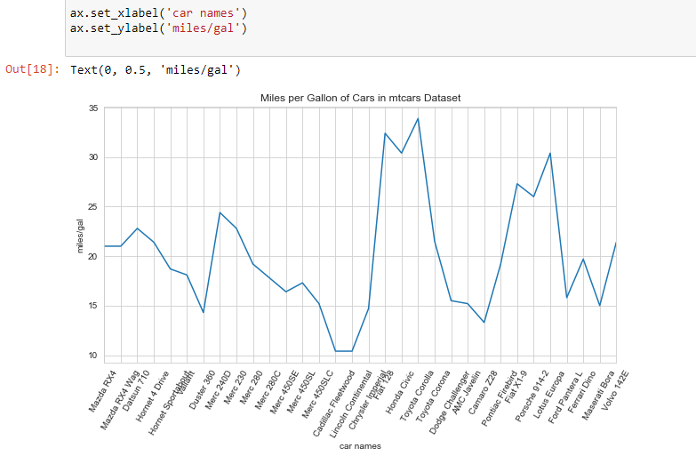

Let’s see how to add legend using Functional Method.

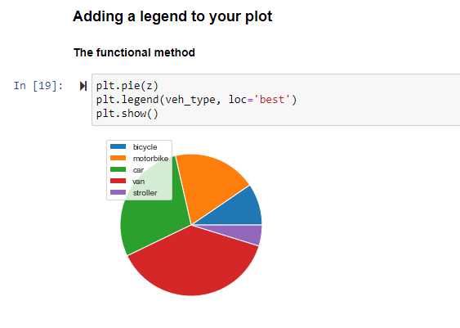

Now will see how to add legends using Object Oriented Method.

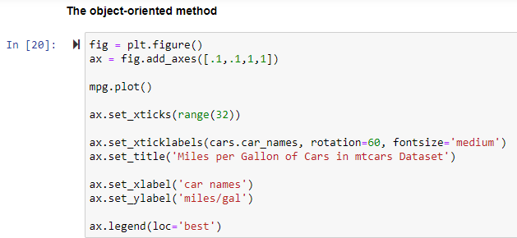

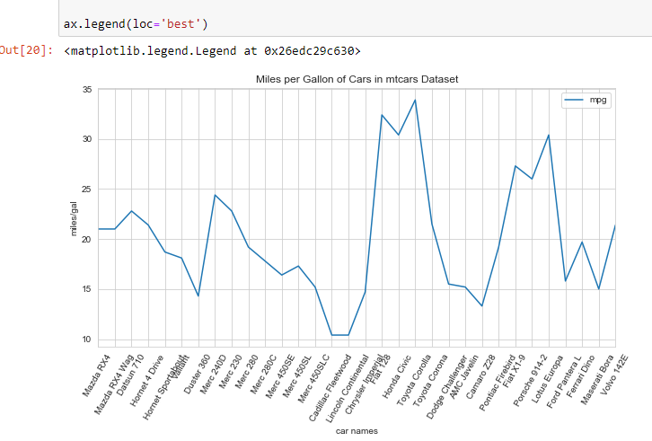

Now let’s see how to annotation in plot.

So first of all fin the max value for mpg. And we will annotate it in the graph.

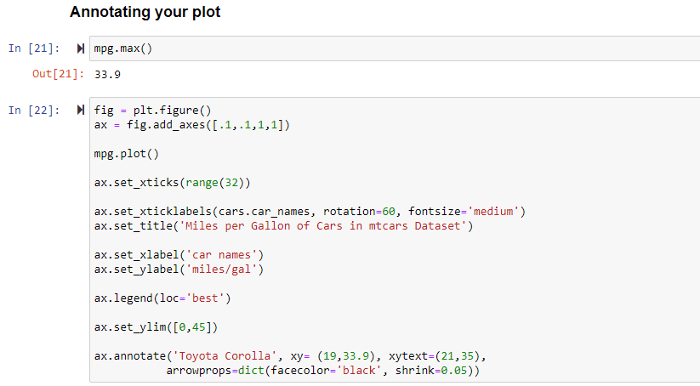

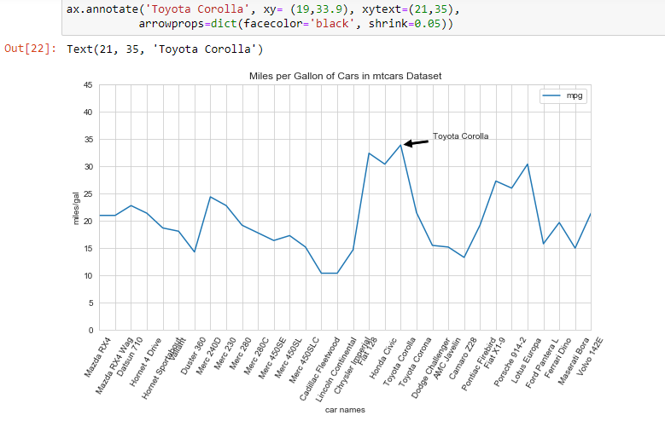

Lecture – 5 :- Visualizing Time Series

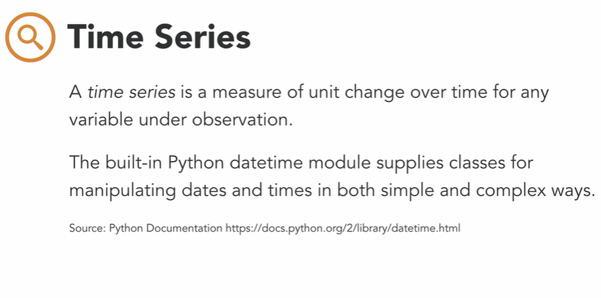

Below are few examples of how time series looks like.

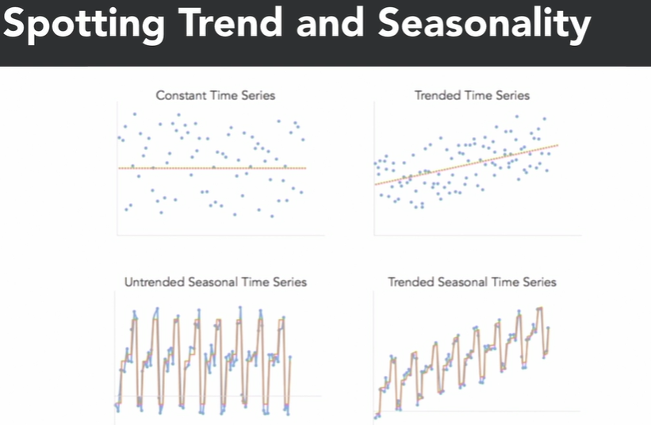

Now let’s see practically, how to plot the time series using pandas.

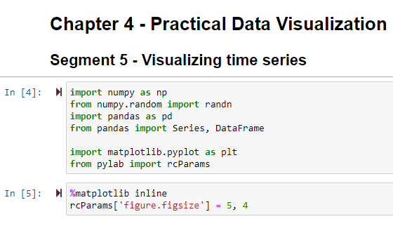

Fetching Data :-

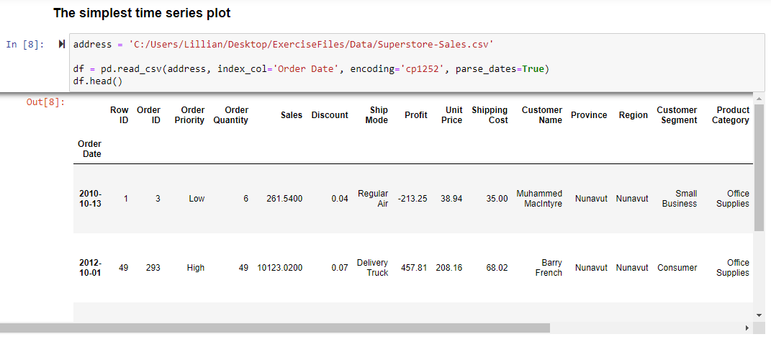

Now plotting it we are plotting Time Series graph for Order Quantity based on Order Dates.

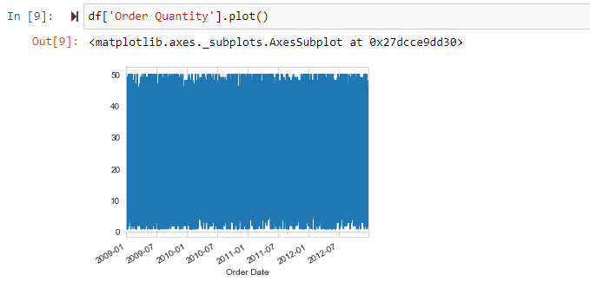

Bt from above, it can be seen that there are lots of data for these particular dates for the Order Quantity . So can’t show this data directly to someone. So let’s just take sample from this data and get some meaningful graph for this data.

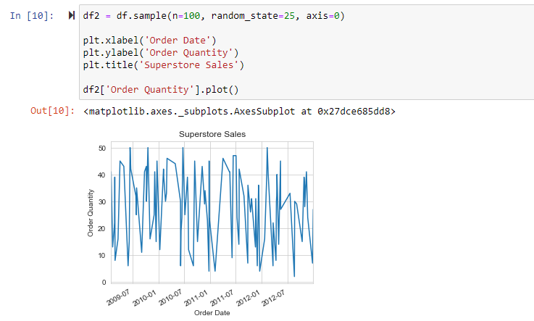

Lecture – 6 :- Creating Statistical Data Graphics :-

Significance of Statistical data graphics:-

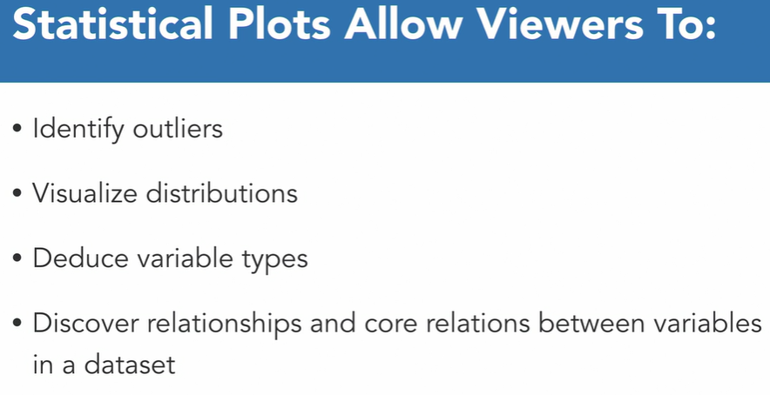

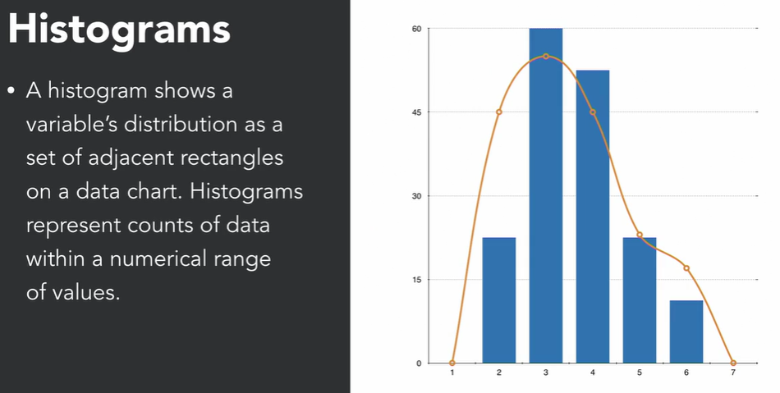

Scatter Plots are used to show relationships between two different variables.

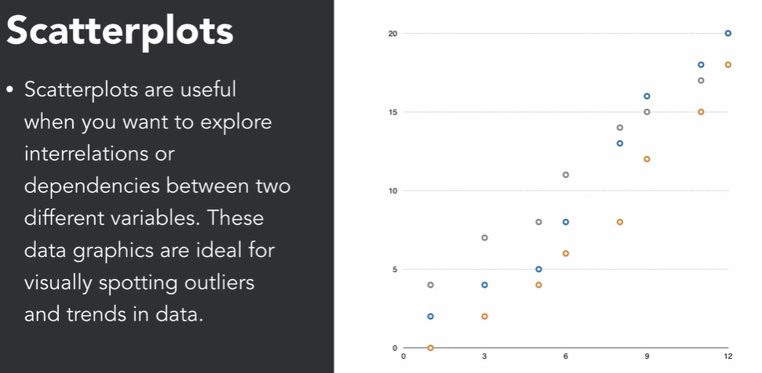

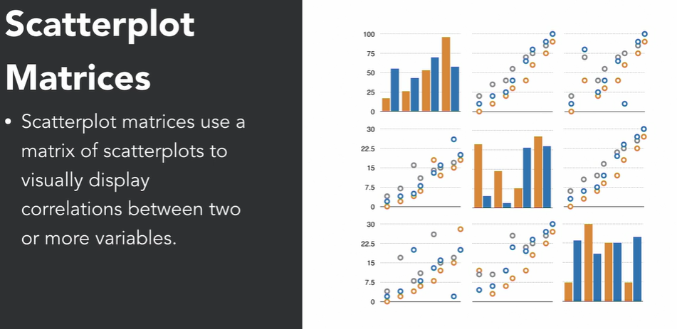

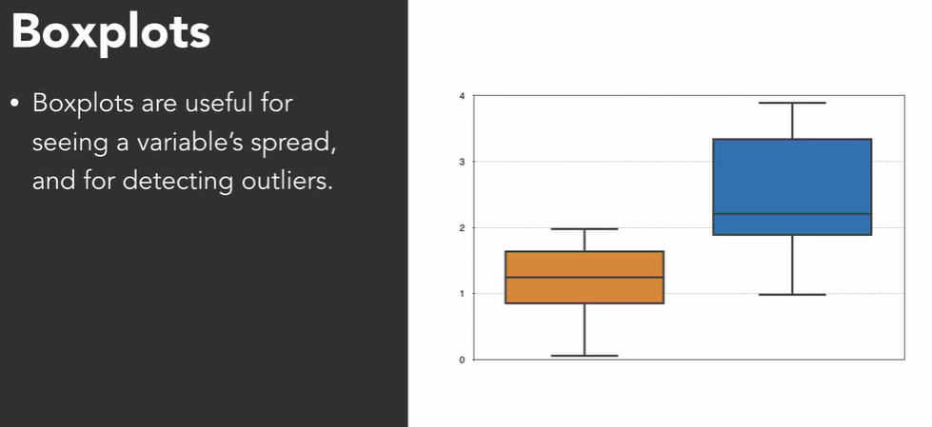

Now let’s see practically how to draw above things in python and using other libraries. In this demonstration we are also going to use seaborne library.

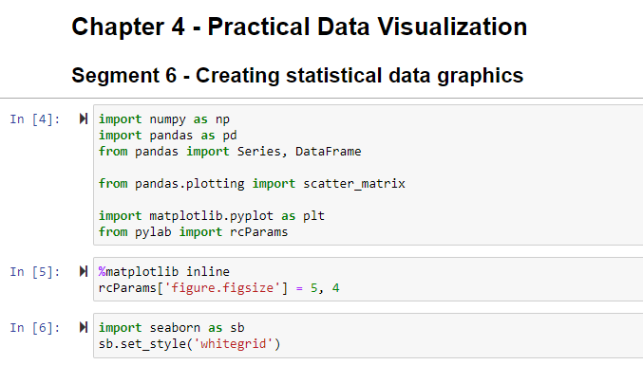

Let’s see how to create histogram. So first of all we need to bring dataset to create the plots then we will create plots.

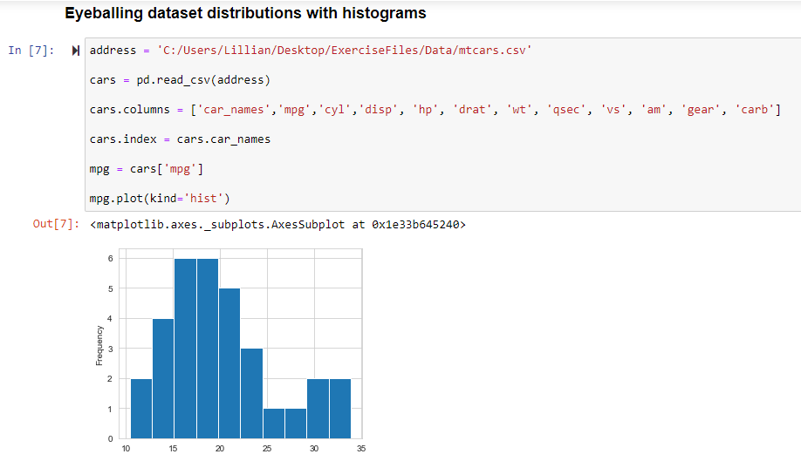

Another method to create histogram is to use hist() function and then use plot() function to show it on the screen.

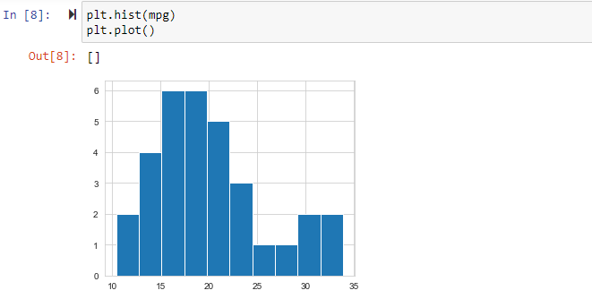

Another method to create histogram is to use seaborne library.

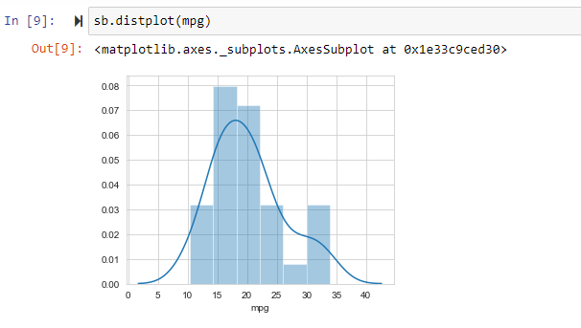

Now let’s see how to draw scatterplot.

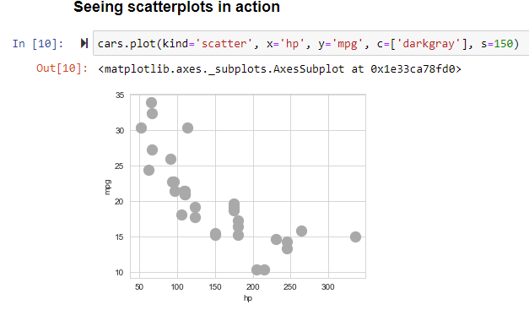

Using Seaborne :-

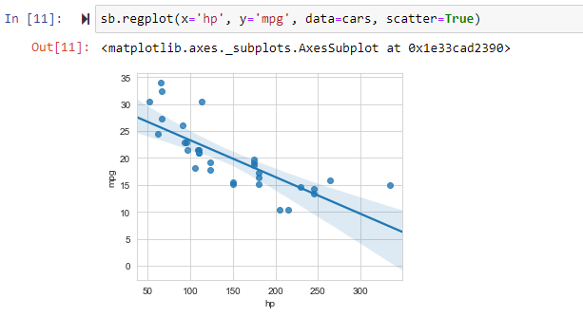

Now let’s see how to draw scatterplot matrices :-

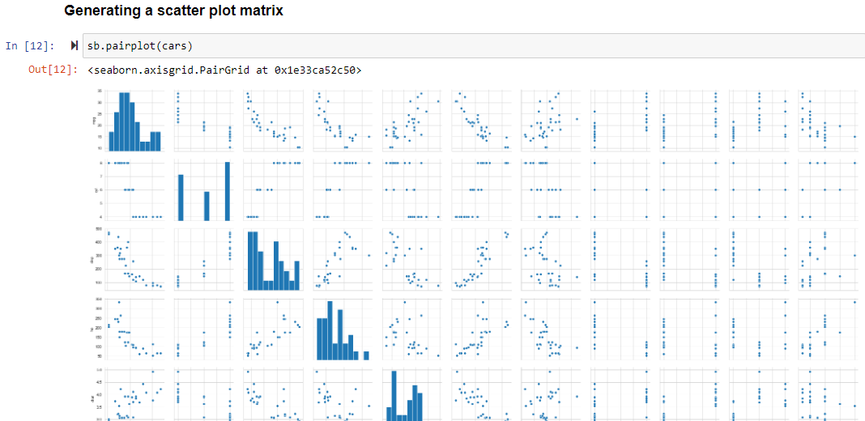

So there are too much information or we can say scatterplot matrices. So first we take only subset out of that. And then draw it.

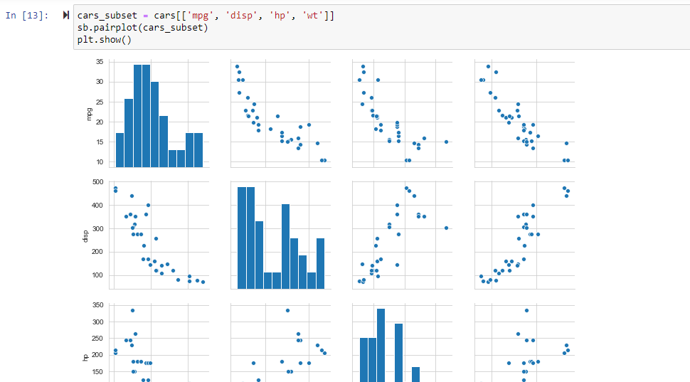

Let’s see how to create boxplot using matplolib.

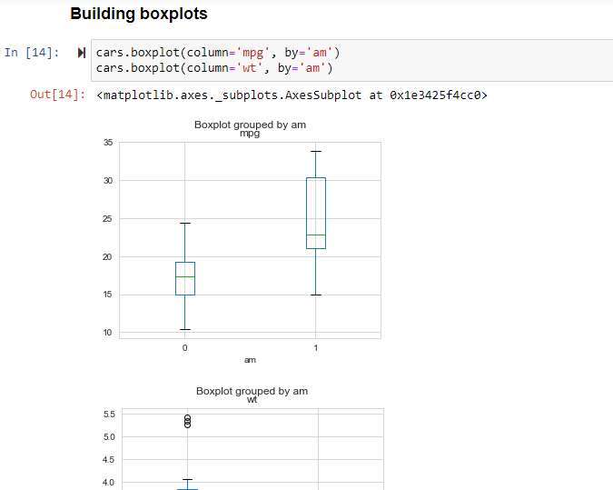

Using Seaborne :-

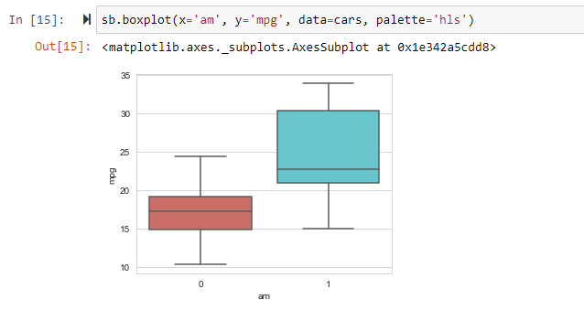

Quiz Questions :-

Q) Which code customizes the line graph parameters of x and y with a dashed line style, size 5 line width, and a size 10 circle marker style?

Answer :-

* plt.plot(x, y, ls='--', lw=5, marker='o', mew='10')

Correct

This code generates a customized line graph with the correct arguments.

Q) Using the seaborn library, which code generates a histogram of the variable hippo from the sample data set df_animal?

Answer :-

* sb.distplot(hippo)

Correct

This is the correct syntax for the seaborn library.

Q) What is the first step in object-oriented plot building?

Answer :-

* generate a blank figure object

Correct

This is the first step in generating a plot for the object-oriented method.

Q) What is generated by the pairplot function in the seaborn library?

Answer :-

* scatter plot matrix

Correct

The sb.pairplot function generates scatter plot matrices.

Q) Which piece of code generates 2 subplot in 2 rows and 1 column?

Answer :-

* plt.subplots(2)

Correct

This code generates the subplots stacked in 2 row and 1 column.

Q) What type of time series graph is represented in the below graphic?

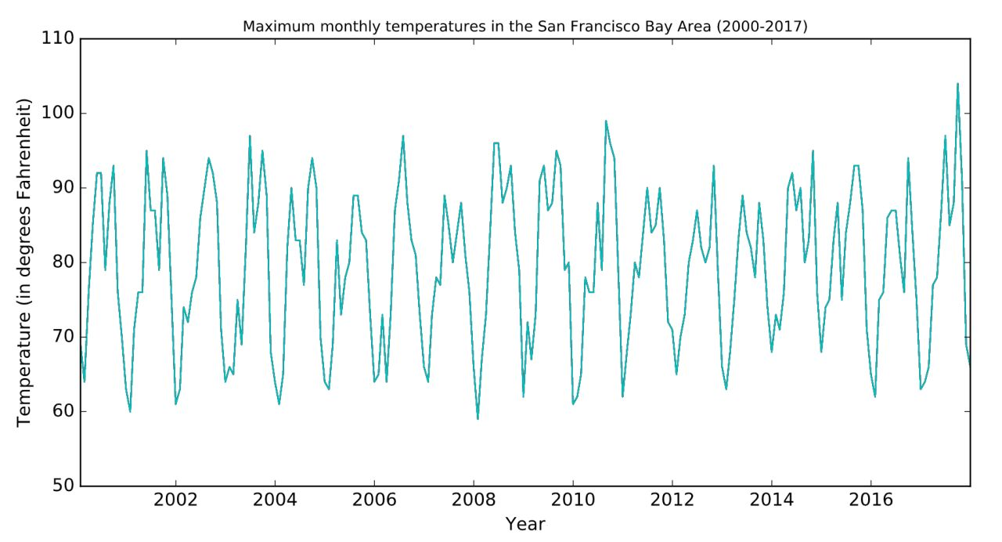

Answer :-

untrended seasonal time series

Correct

This time series variable increases and decreases periodically without a net change over time.

Q) Using the mtcars data set, what is the code to create a horizontal plot from the qsec variable?

Answer :-

qsec.plot(kind="barh")

Correct

This code generates a horizontal plot of the qsec variable

Q) What is a trended seasonal time series plot?

Answer :-

* a plot whose time series variable does not increase and decrease periodically with a net change over time

Correct

This is a trended seasonal time series plot.

Q) What is the difference between line charts and bar charts?

Answer :-

* Line charts display changes overtime and bar charts display changes in categorical data.

Correct

Line charts display the change in two variables overtime and bar charts display the counts of observations within categorical data.

Pie charts display categorical data as a proportion of a whole and bar charts display changes in categorical data.

Q) What does the mew argument represent in the plot function for the matplotlib library?

Answer :-

* marker edge width

Correct

The marker edge width argument is mew.

Q) What is the default legend position in Python?

Answer :-

* location string='upper right' and location code=1

Correct

The upper right location is the default legend position.

Q) Which code customizes the line graph parameters of x and y with a dotted line style, size 5 line width, and a square marker style?

Answer :-

* plt.plot(x, y, ls=':', lw=5, marker='s')

Correct

This code generates a customized line graph with the correct arguments.

** Module – 5 :- Basic Math and Statistics :-

Python provides libraries for mathamatics and statistics as well. In this module we will going through it. Example of such libraries in python are Numpy, Pandas, Scipy etc.

Lecture – 1 :- Simple Arithmetic :-

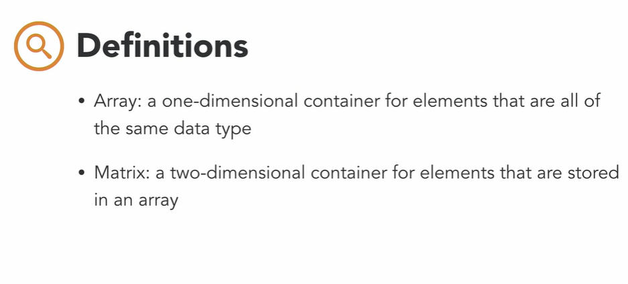

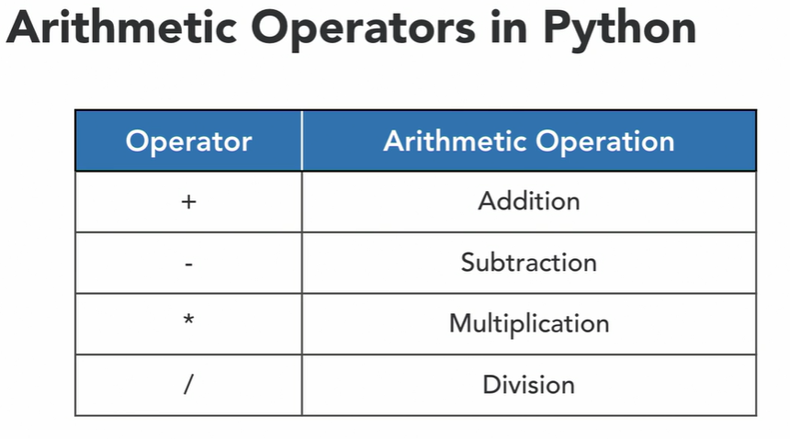

As in numpy, it shows full decimal values. Bt we only want 2 digits after decimal point as of now. So we can set it as showing in below image.

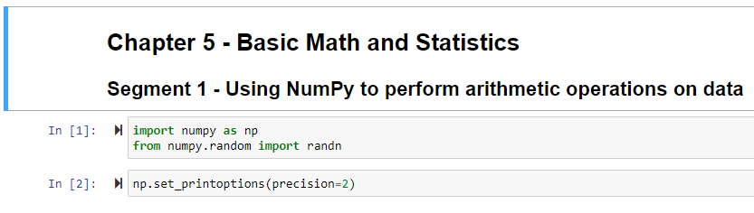

Let’s see how to create array in numpy.

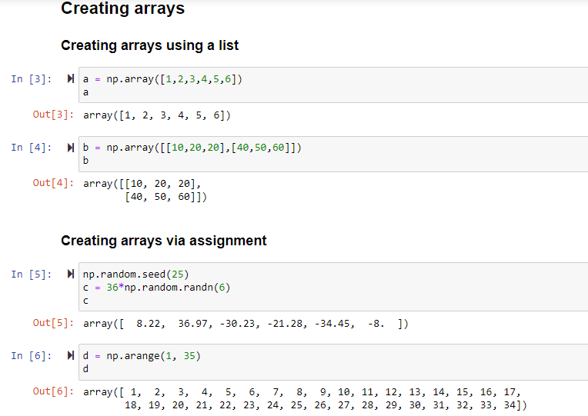

Please note one thing is, whenever randn function of random module is used, it will generate both the positive and negative type of numbers.

Now let’s see how to perform arithmetic on array. It is actually very very very simple and straight forward using numpy.

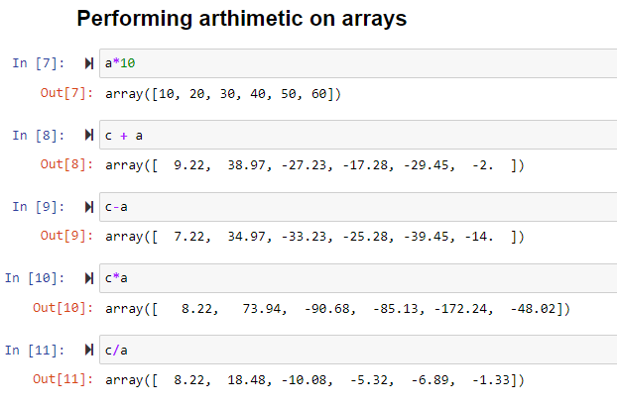

Lecture – 2 :- Basic Linear Algebra

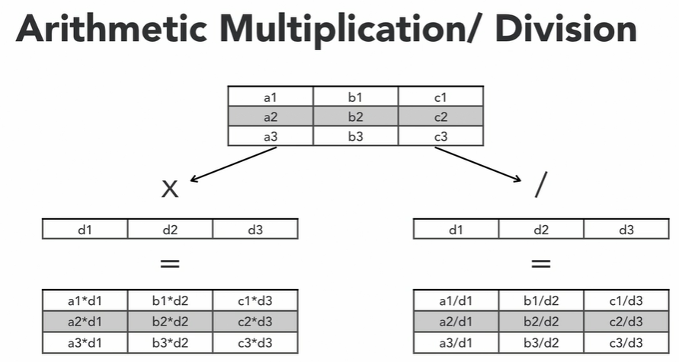

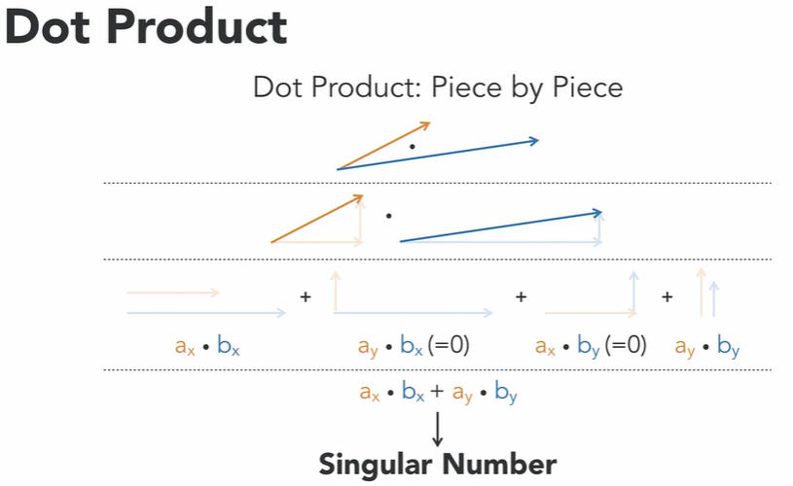

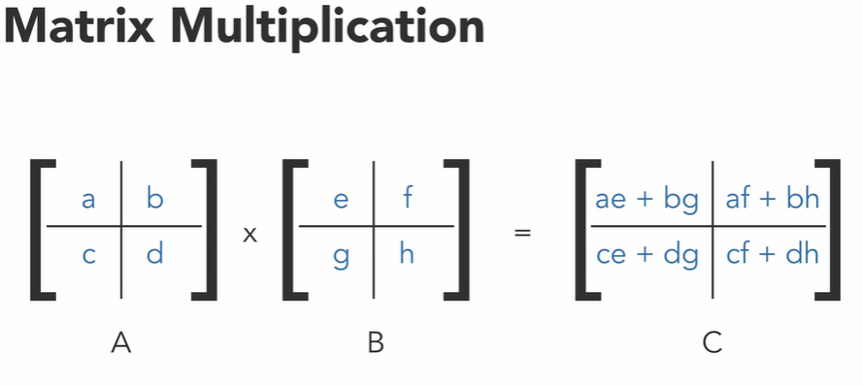

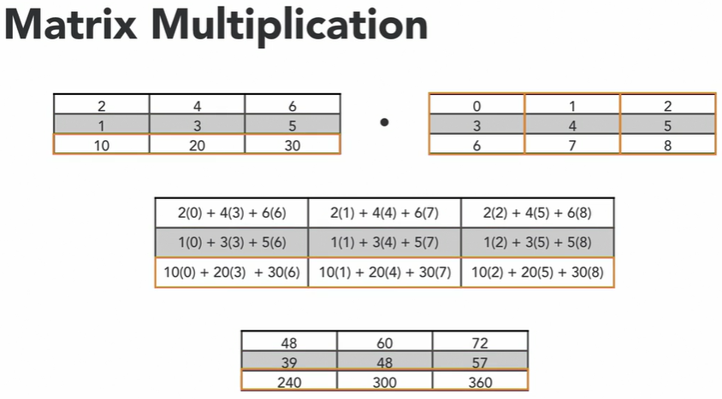

Let’s see how to perform linear algebra practically using Numpy.

To perform matrix ultiplication we need to use np.dot(matrix 1,matrix 2) function. Actually this is the only function which is used for both dot multiplication and matrix multiplication. If we pass matrix as and args then it will perform matrix multiplication else it will perform dot multiplication.

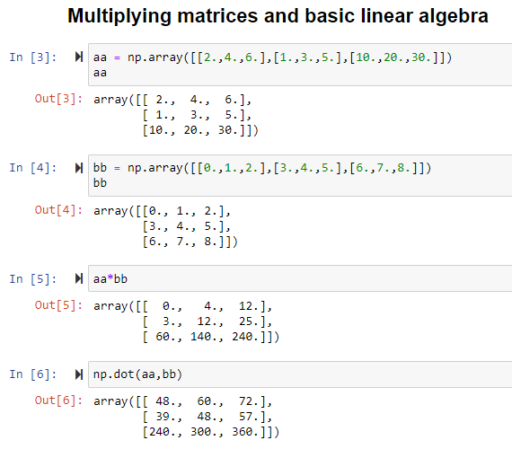

Lecture – 3 :- Generating Summary Statistics

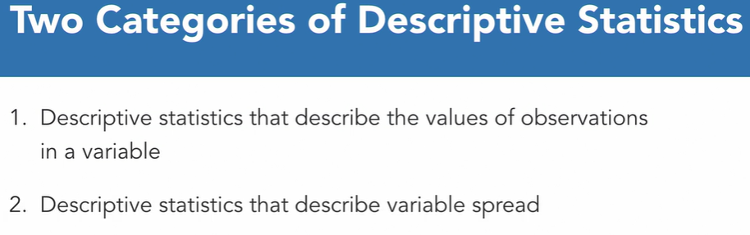

So if u want to know the descriptive statistics like values of observations that you should use below parameters or you should find below left side parameters for all the observation presents in the particular variable. Else for variable spread u should look for the right side parameters.

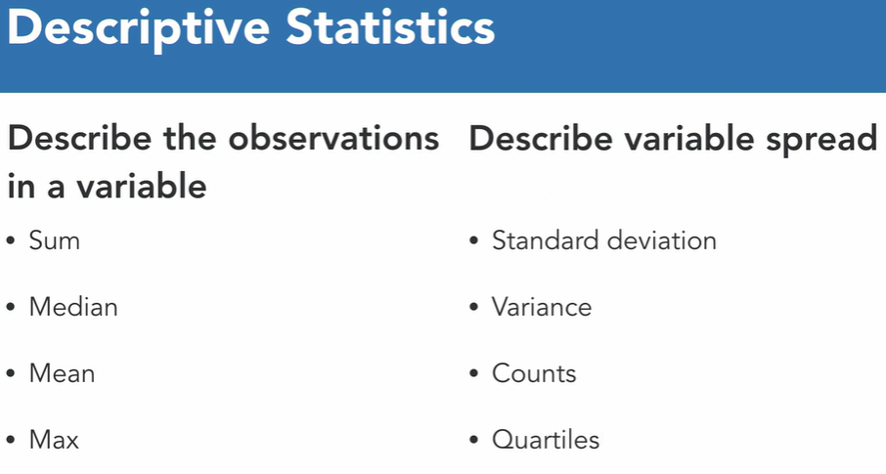

Uses of Descriptive Statistics :-

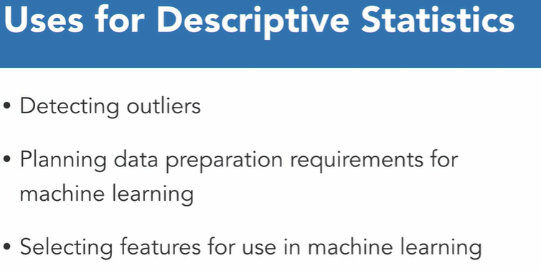

Let’s see how practically find the descriptive statistics in python.

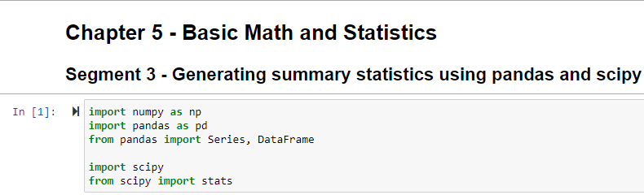

So first we need to load the data.

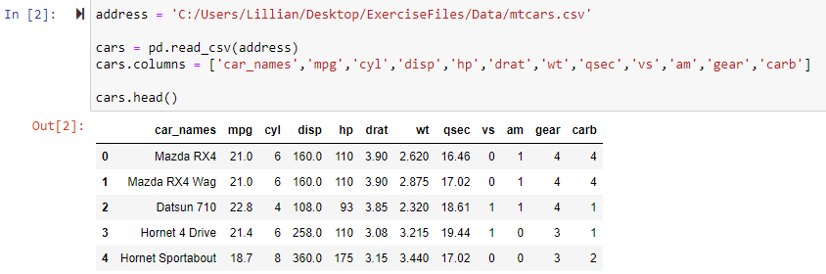

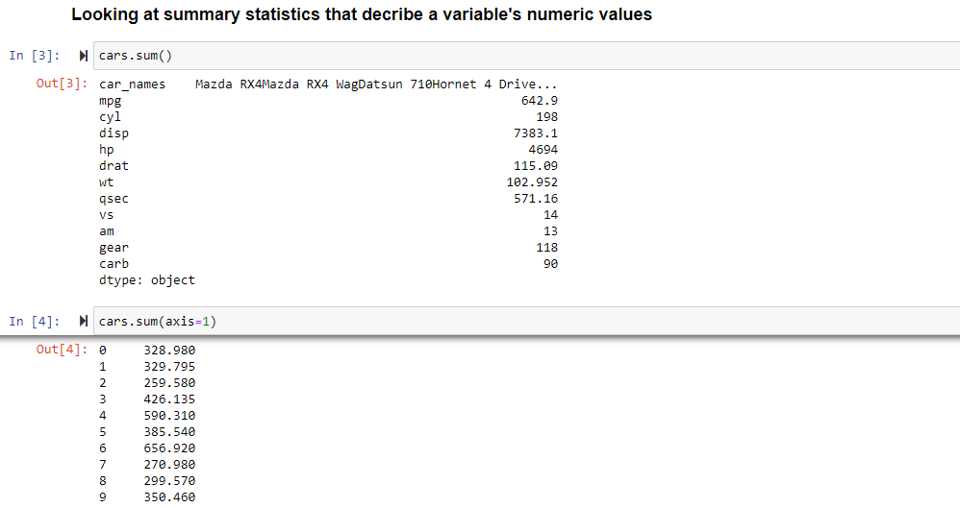

Sum method can provide sum of all the values in a particular column or in a particular row. Bt remember by default sum method will provide sum of values of a column. To find sum of values of a row, we need to specify axis=1 as an argument.

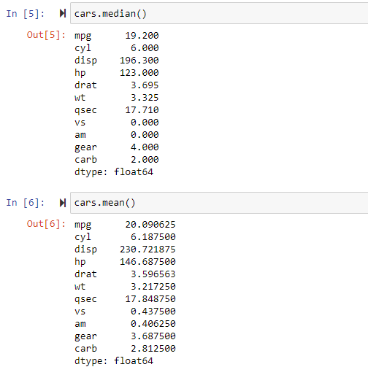

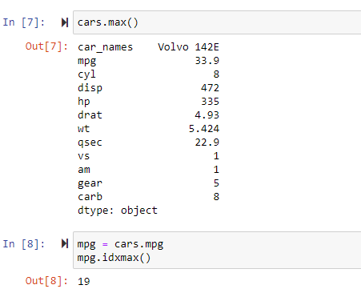

To find from which row max value come from, we need to use idxmax function as shown in above image. It will return the index of that row from which maximum value comes from.

Now let’s look at the numeric data statisics using python.

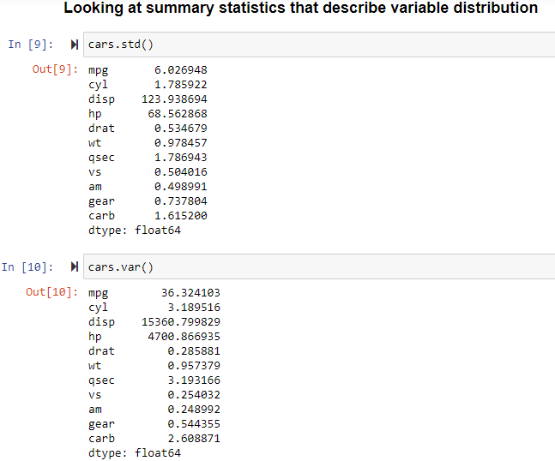

To find the count based on the unique values present in particular variable, value_counts ( ) method will be used. It is similar of finding count(distinct) group by some column. And one thing to note is if you need to find all the numeric statistics for the variable, then you can use describe( ) method.

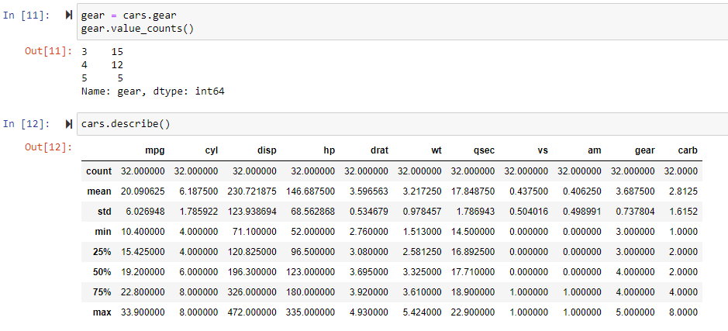

Lecture – 4 :- Sumarizing Categorical data :-

Categorical Data describes as how observations is distributed across the variable’s category.

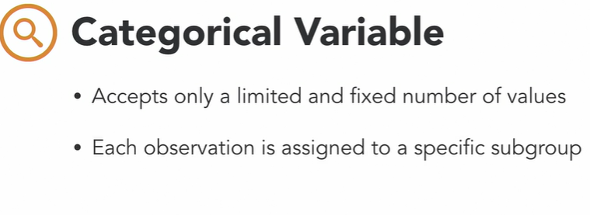

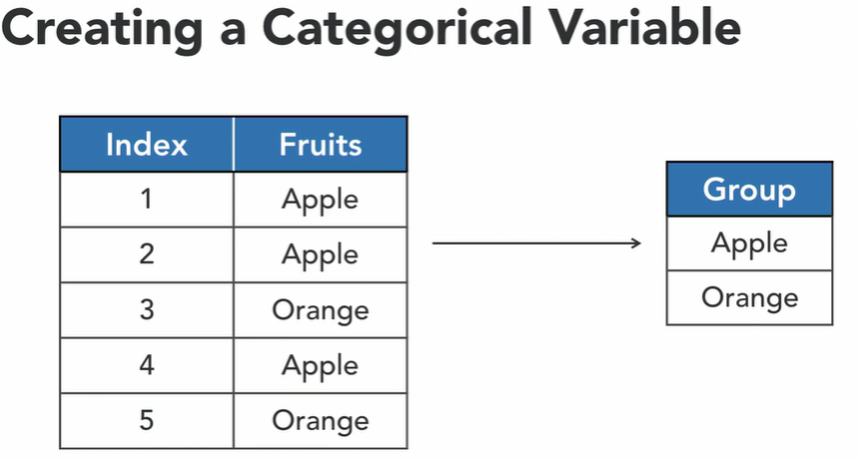

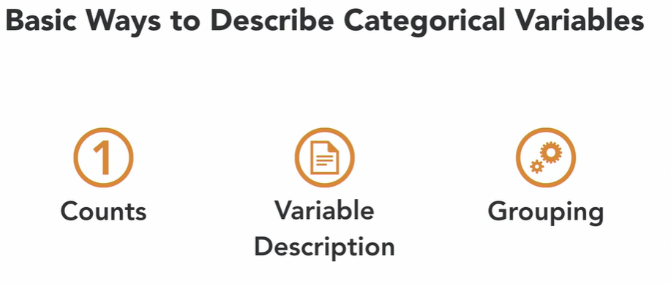

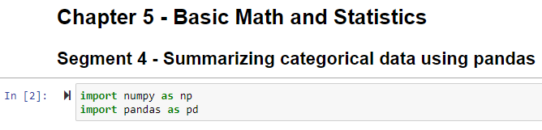

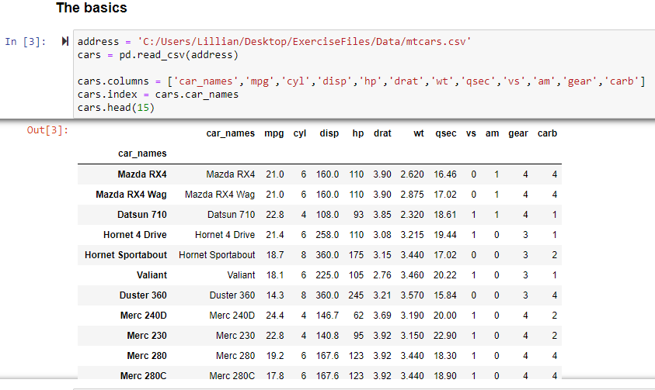

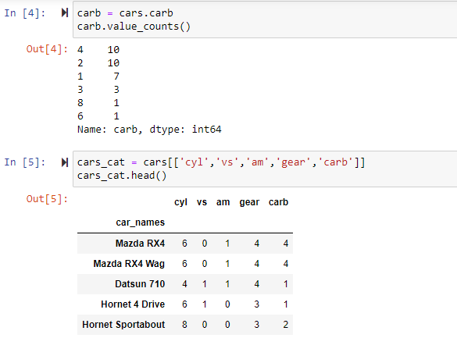

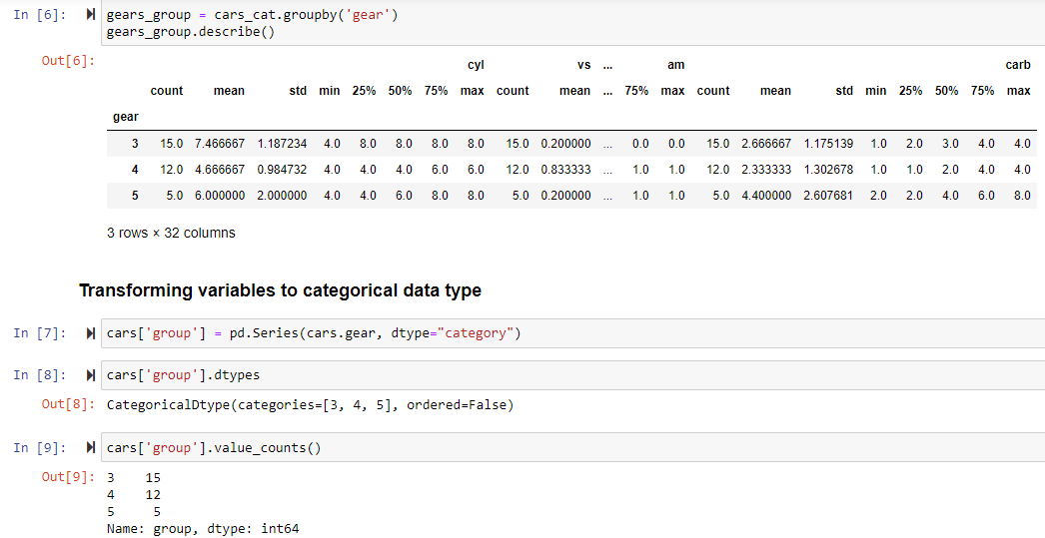

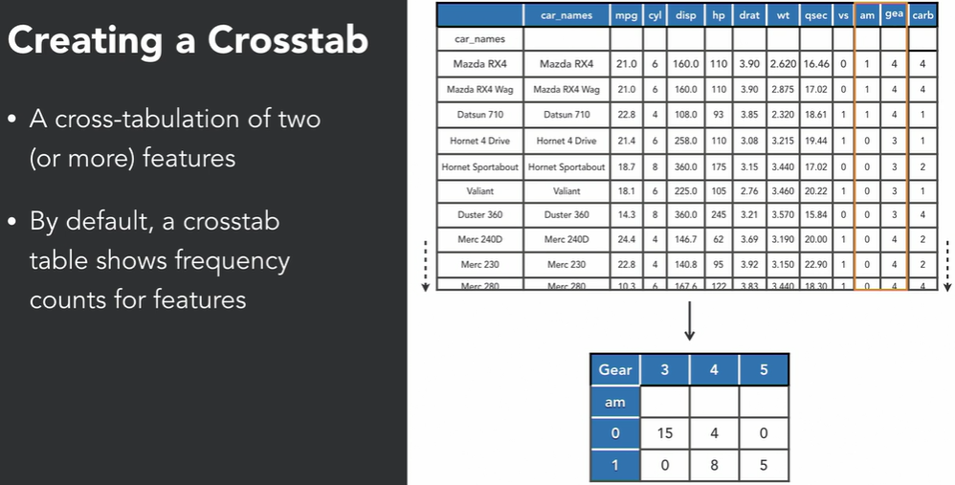

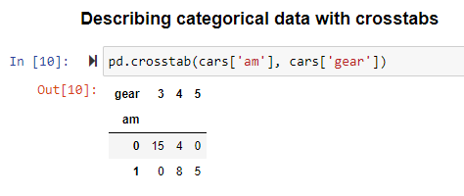

Lecture – 5 :- Parametric Correlation Analysis

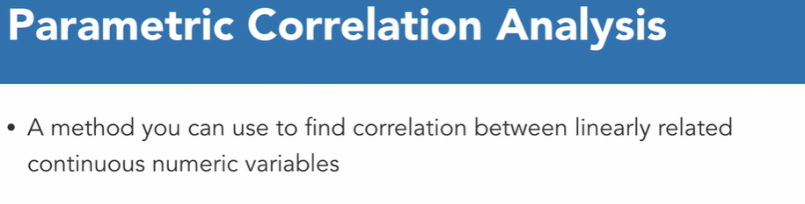



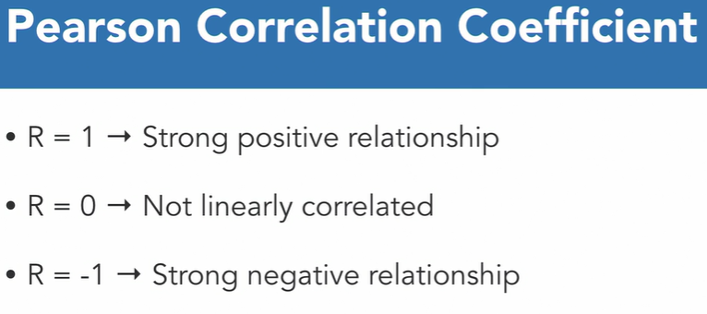

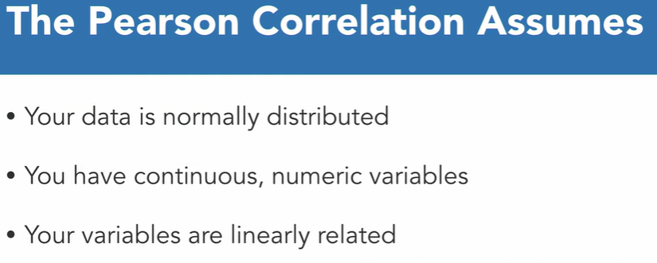

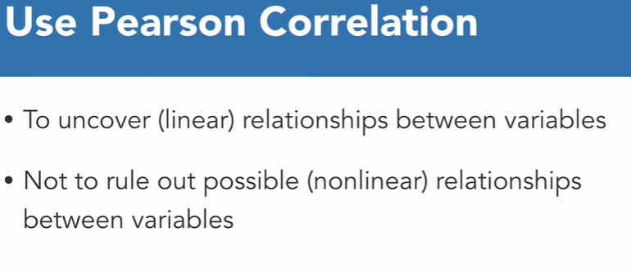

Below are the example of scatterplot which doesn’t have continuous random value variable hence not eligible to find analysis using Pearson correlation method.

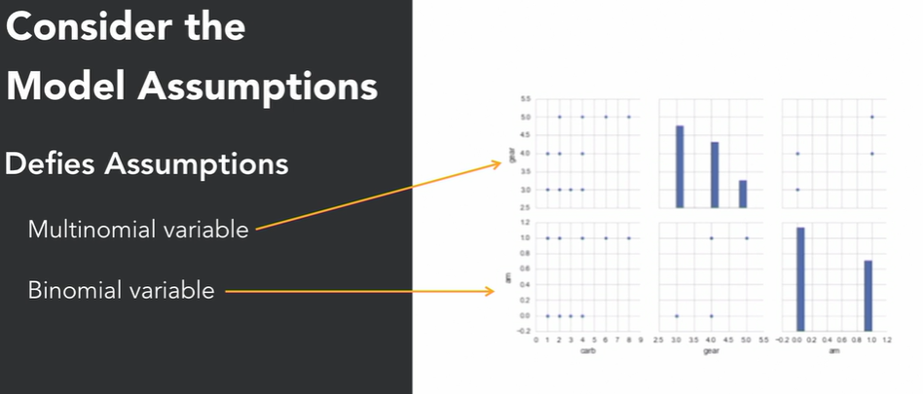

Note :- For continuous numeric variables, scatterplot of variables are much more randomly and evenly distributed.

So steps might be :-

Step – 1 :- First find the categorical variables (Categorical variables might be continuous numeric varible or non continuous variable.).

Step – 2 :- check weather those variables are eligible for Pearson correlation analysis or not (check it just by finding the scatterplots of that particular that variables).

So let’s see how to practically do it.

Setting up all the require libraries.

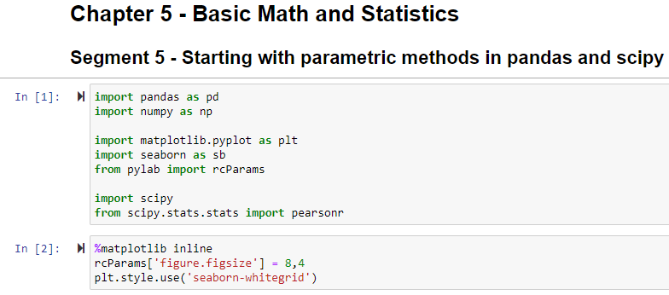

Importing dataset to find the pearson correlation. And then try to check the scatterplot, weather categorical variables are eligible to apply pearson correlation method as we know pearson correlation has 3 assumptions or we can say those 3 things must be satisfied to apply pearson correlation method.

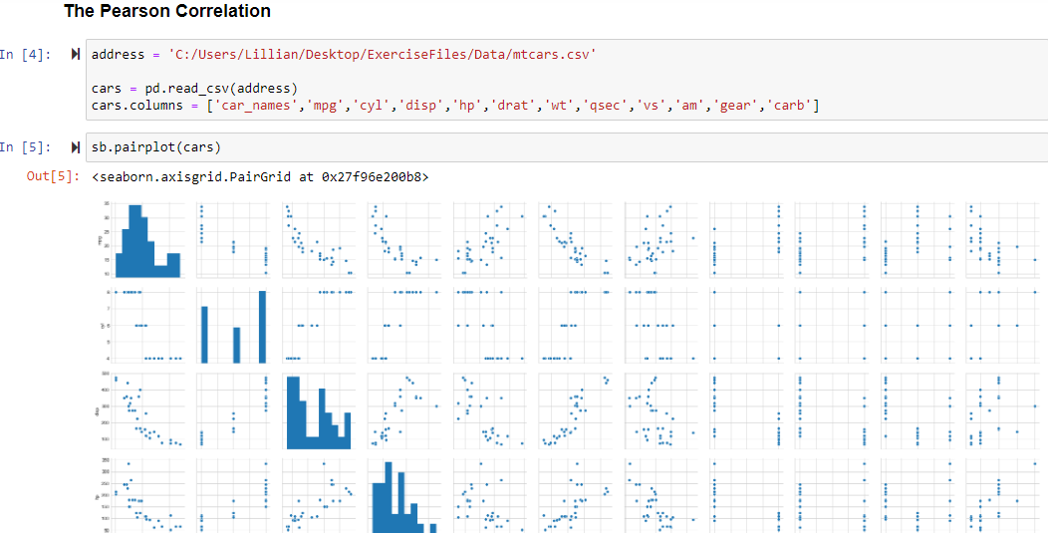

Only Checking for few categorical variables not for all.

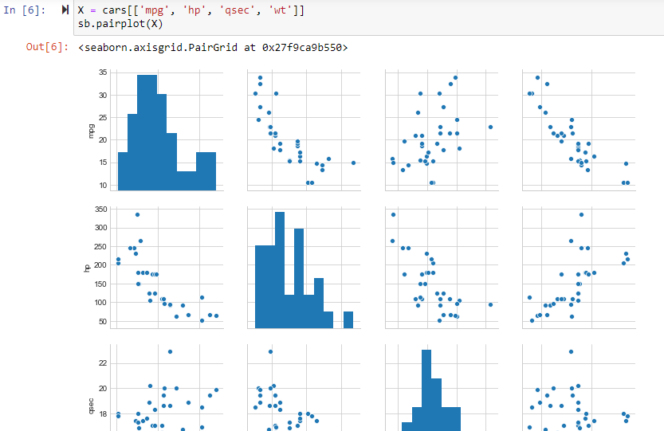

Finding Pearson coefficient using Scipy for finding relationship between 2 continous linear variable.

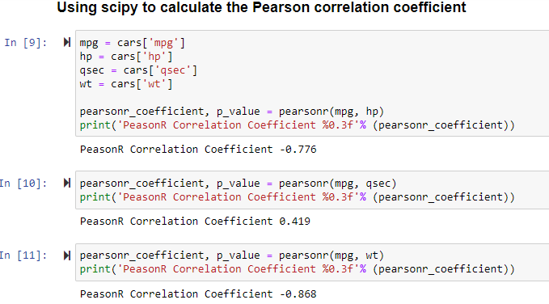

Just for the information, from above image we can see that variable ‘mpg’ and ‘wt’ are strongly corelated to each other.

Using pandas to find correlation coefficient :-

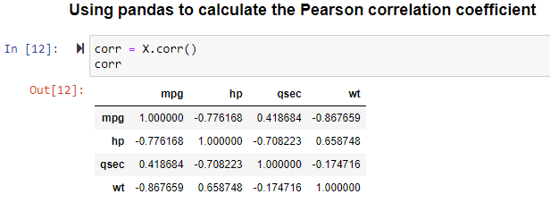

Using Seaborne try to visualiz and find the correlation :-

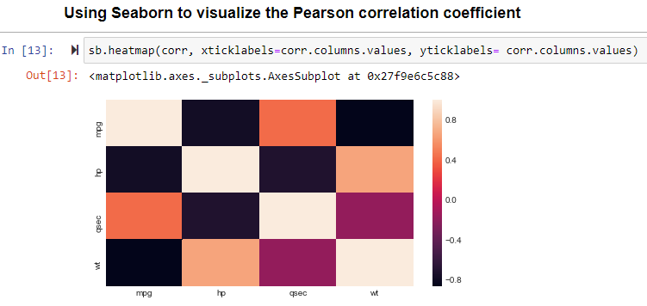

Just FYI, darkest color indicates less correlation and lightest color indicates more correlation between those 2 variables. Or that can be concluded based on scale given at right side.

Lecture – 6 :- non parametric relational analysis :-

So in this lecture, we will try to find the correlation between 2 non linear variables.

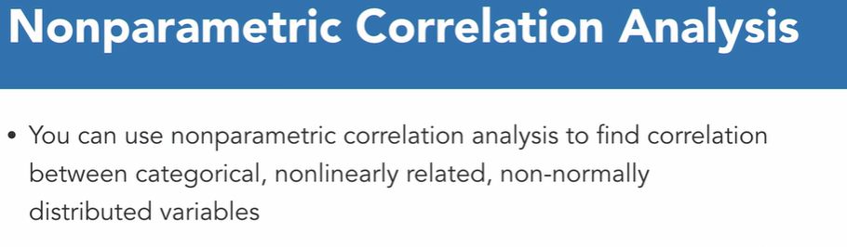

Methods used to perfor Nonparametric Correlation Analysis :-

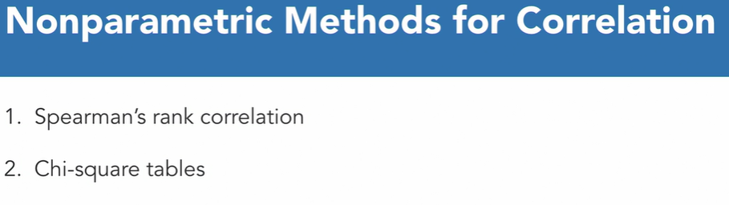

Spearman’s rank correlation is used to perform analysis on ordinal variables. (ordinal variables means those variables which can be categorized ) .

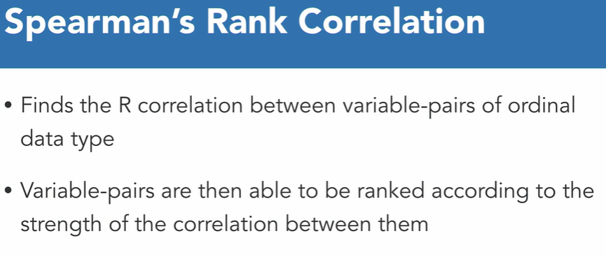

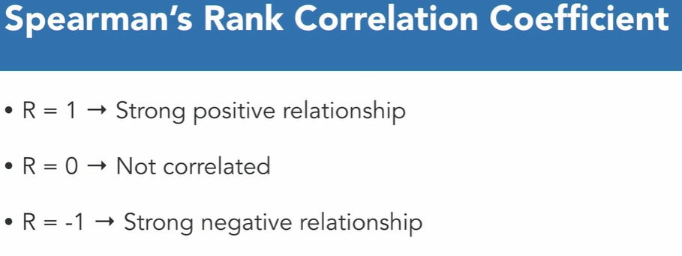

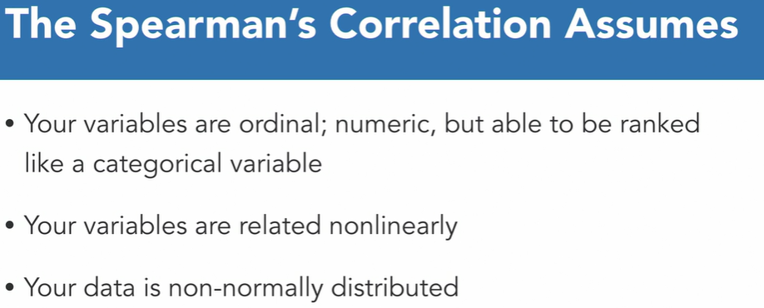

Chi – square method to check the correlation between variables.

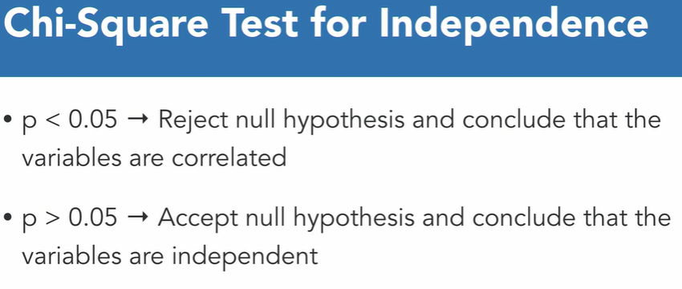

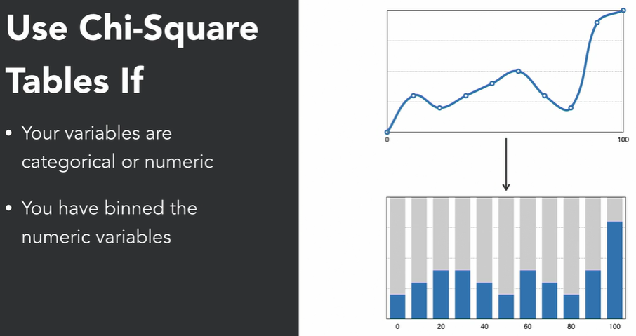

Binning means suppose for example, I am having values 1 to 100 in a variable. So binning means I am able to group it. So I can group it 10 values a group and having 10 groups.

Let’s see above things practically.

Jst setting up the libraries.

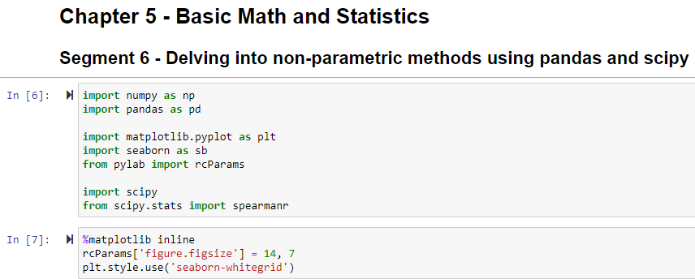

Importing or loading dataset.

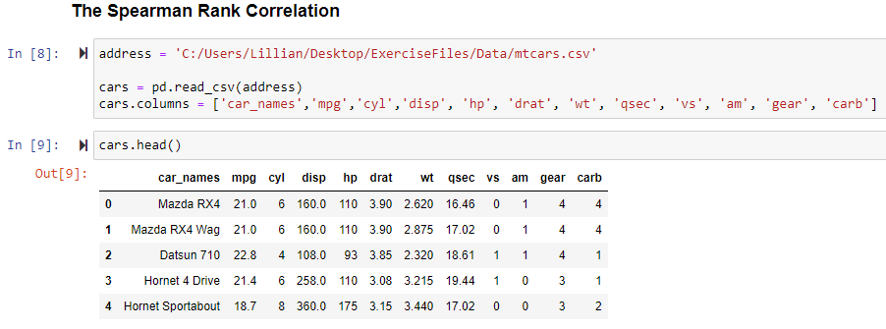

Now jst printing scatterplot to check weather variables are meeting those spearman’s assumption or not.

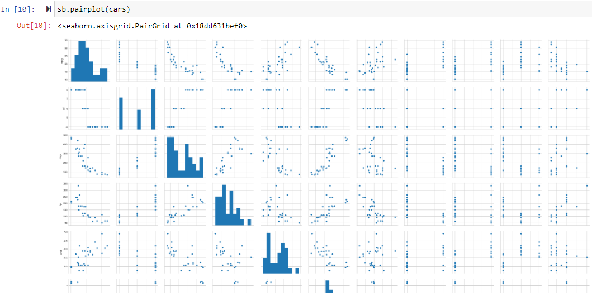

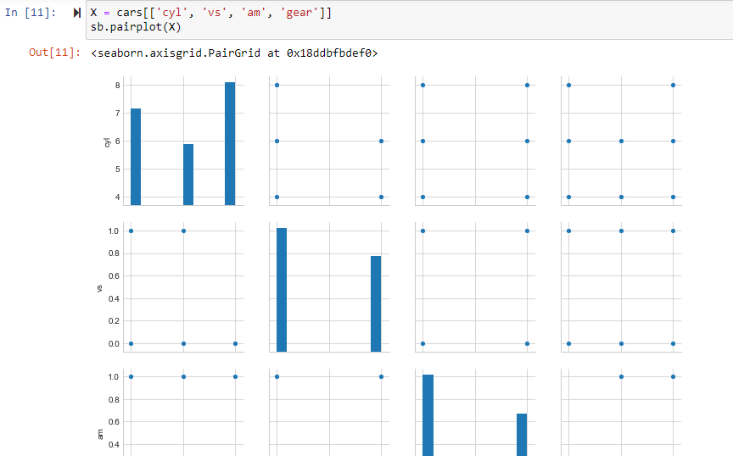

Why I chose those above variables only?

Because those variables are ordinal variables. It mans those variables are having numerical and it can be categorized, as I have checked each variables having few different numeric values hence can be categorized. Hence those are ordinal variables.

Are these variables related non linearly?

So from the scatterplot matrices we can see that all those variables are non linearly related.

Last question is, is the data distribution is non-normal?

So yes from the histogram we can see that.

So from the above 3 reasons I have decided to choose this 4 variables to test relationships.

So next step is to isolate the above 4 variables and store them in separate variables to test them.

Then apply separmanr function to find the spearman coefficient.

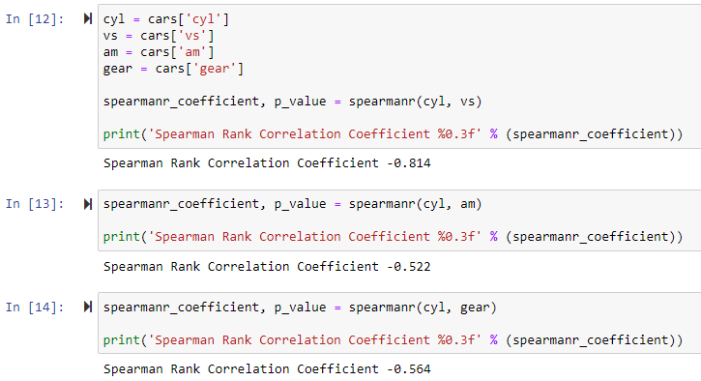

Now let’s perform chi squre test to check independency.

So first step to perform chi test is to make the variables into crosstab. And then to perform chi test we need to import chi2_contingency from scipy.

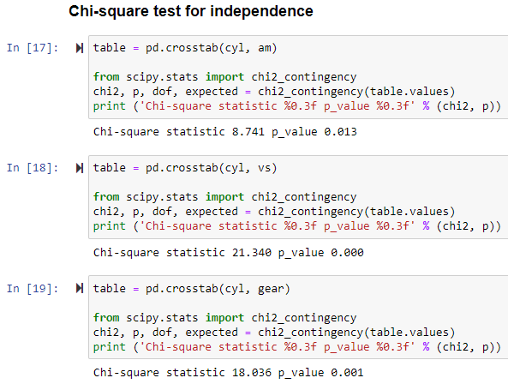

Jst FYI, so as per chi test, if p value is greater than 0.05 then we can say that those 2 variabes are independent from each other. Bt here from above SS we can say that non of the 2 variables are independent with respect to each other and all those are some how correlated.

So now we know how to check the correlation between to variables. So now let’s see how to transform dataset.

Lecture – 7 :- Transforming Dataset Distributions :-

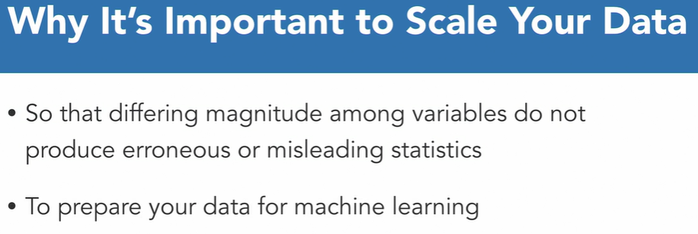

Sbse pehle hme ye question hoga ki muje data ka magnitude scale krna kyu he ryt? So for example, assume this situation. Suppose you launched campaign in 1990. Similar or same campaign you aunched in 2016. Now you have been given task to analyse sales data for this 2 campaigns. So now you checked, during your campaign in 1990 your checkout price increase by 20$. And during campaign in 2016, your checkout price increase by 200$. So now jst think. Can you say this is increased due to more effective campaign ? nope means there are other factors as well like inflation in market, etc etc uski vjh se price to increase hona hi tha. Bt muje to sirf campaign ki vjh se sales me jo revenue me frk pda vhi check krna he na ki dusre sare factors ki vjh se. to isliye hm log dono data ko same magnitude s scale krenge taki vo erroraneous result na de.

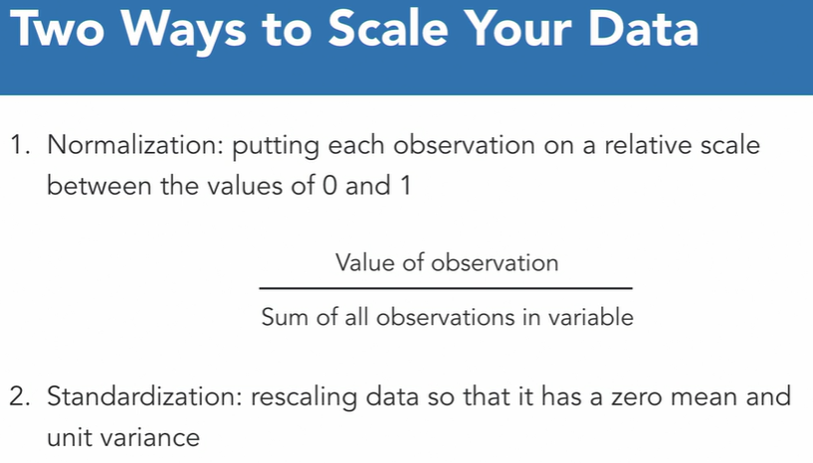

So there are 2 ways to scale the data. Normalization nd standardization. So normalization is like we did in high school like to find grade of any exam or test, we are just finding grade based on how many questions I missed during exam out of total.

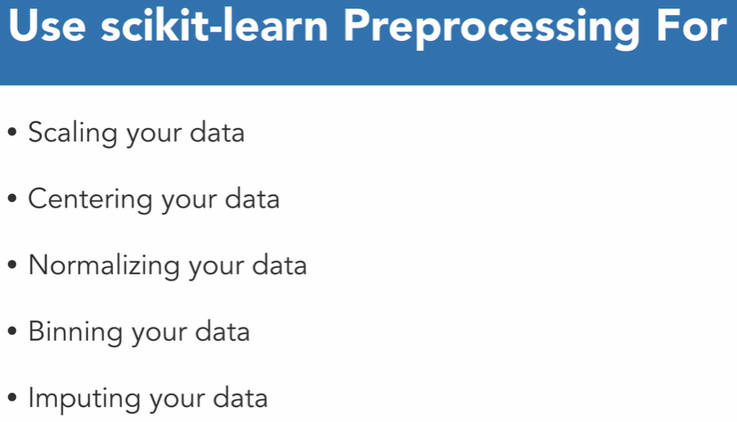

So in this demonstration we will see scalling and normalizing function in scikit only.

Let’s do it practically.

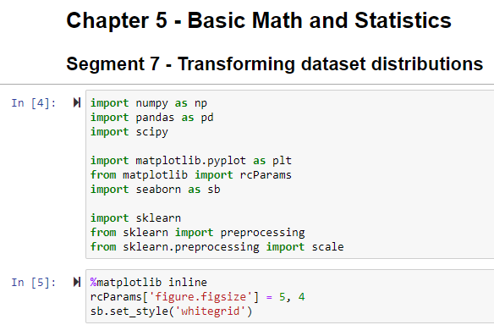

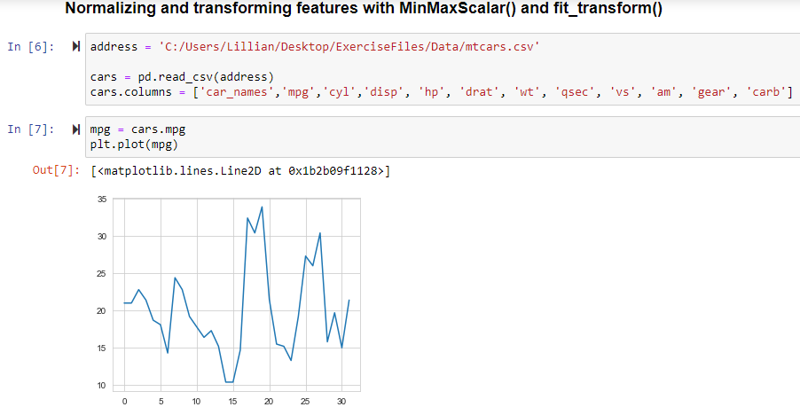

So first import or load the data. Then we are just taking one variable ‘mpg’ and checking it’s plot. Then we jst need to get summary statistics for that variable. To do that we can use describe ( ) method as it gives all the summary statistics for particular variable.

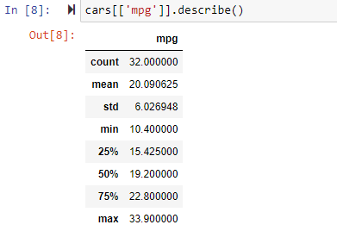

Then first thing we need to do is we need to transform the variable data in one – column matrix.

After it, let’s instantiate min/max scaler object.

Min/max scales the functions we used to transform our variable by scaling it to a defined range. By default that range is between 0 and 1.

Then we want to call the fit_transform method in order to fit the min/max scaler transformer to our data and returned transformed version of that data. After it u can jst check by plotting it. So from graph u can see like plot is same. It means distribution of data is same. Bt the scale range (on y axis) is changed to 0 and 1.

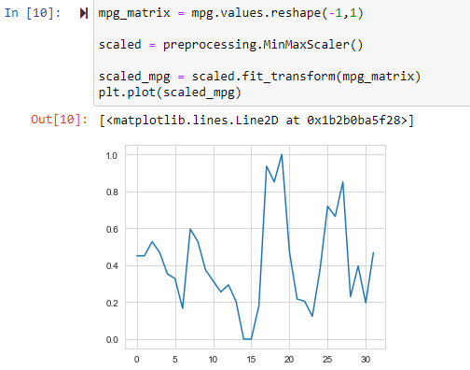

Now one more thing is, that range of scaling is by default 0 to 1. Bt if u want to scale the variable between some different range then you can pass argument for exa.:- feature_range=(0,10)

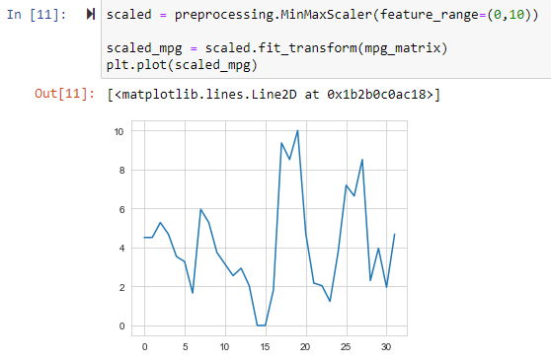

Now after scaling, let’s standardize the features. To standardize we just need to use scale () function. By default this function center the data and scale it to unit variance.

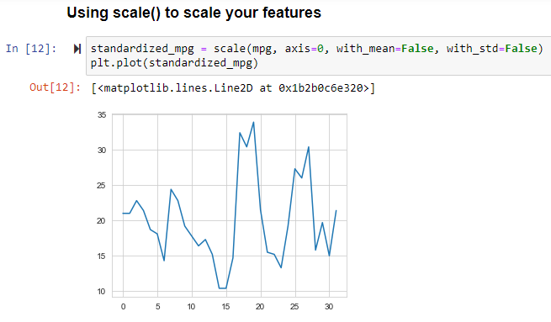

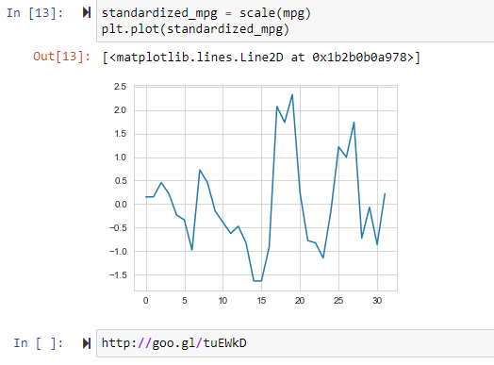

Lecture – 8 :- Extreme Value analysis for Outliers

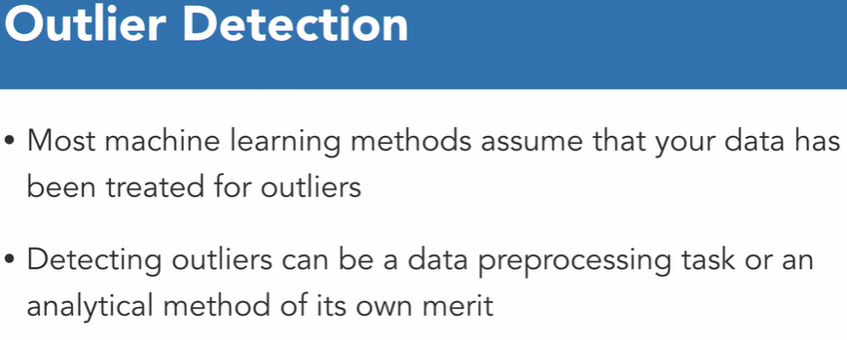

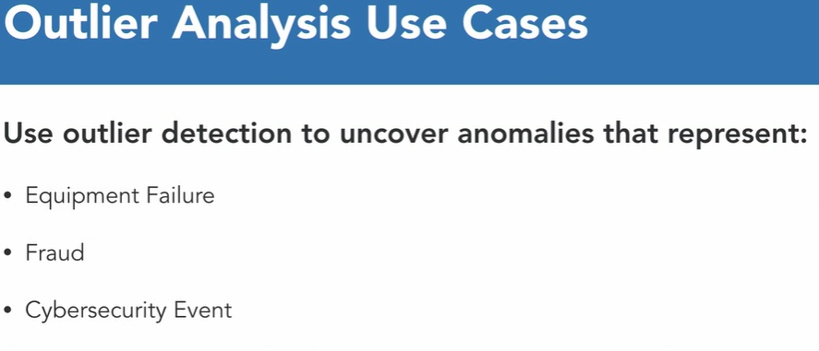

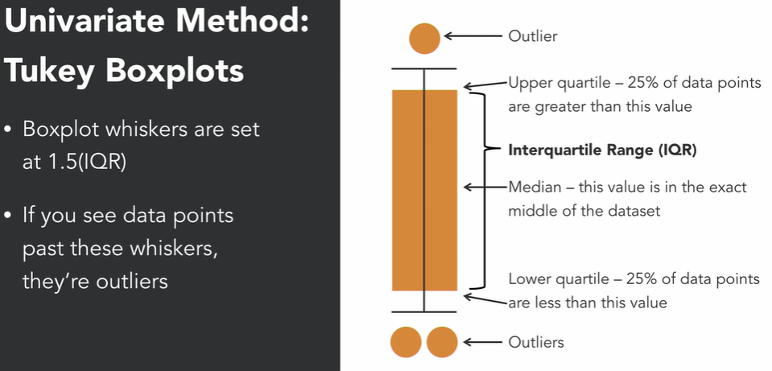

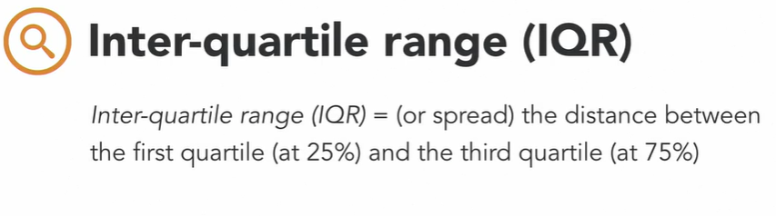

Another method is univariate method. This is nothing but mathematically performing outlier.

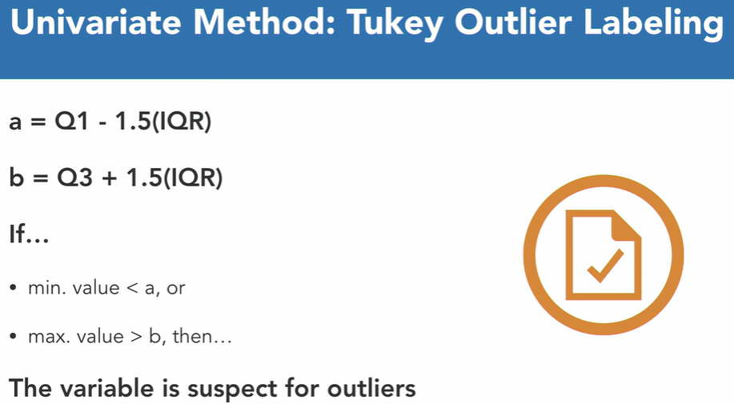

Let’s do it practically.

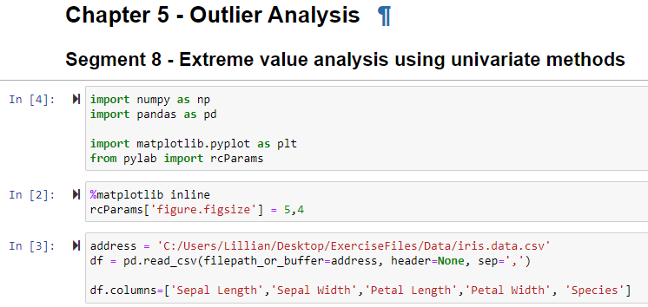

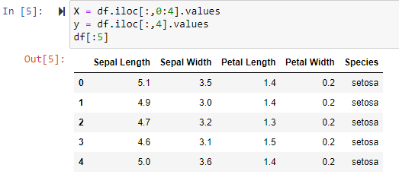

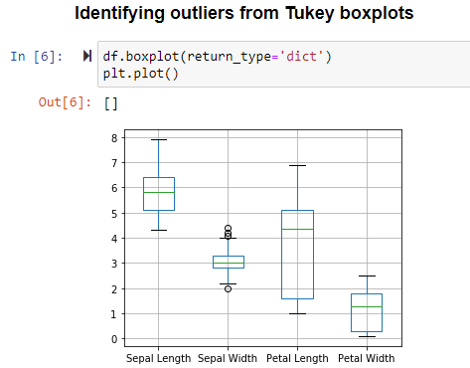

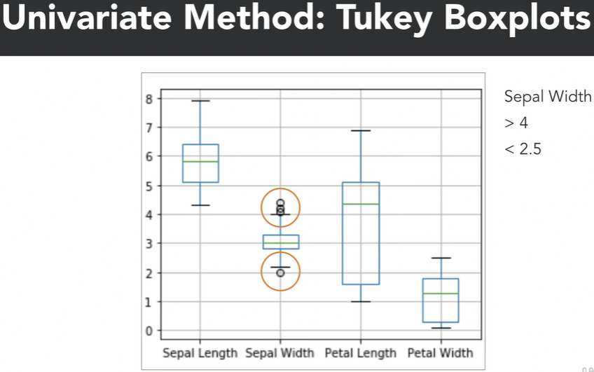

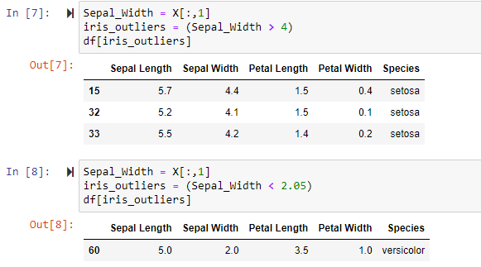

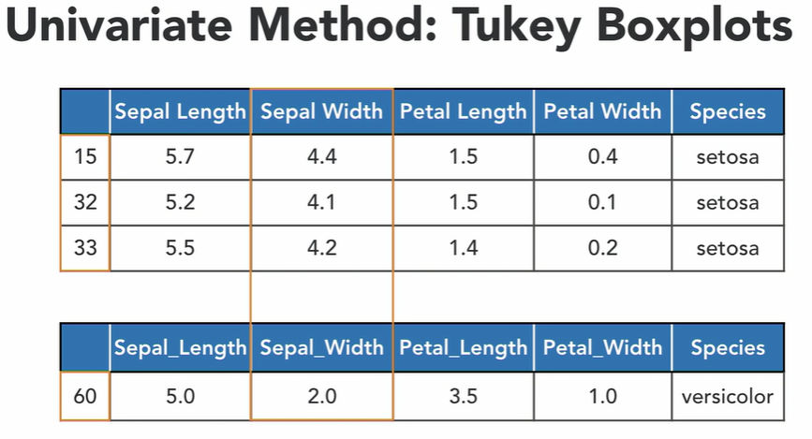

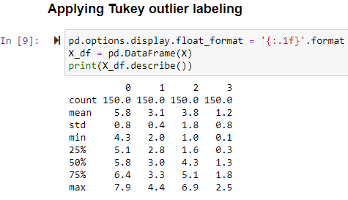

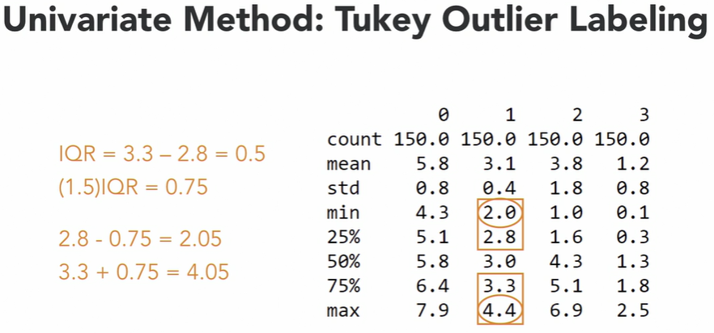

Next we will see Univariate method.

Lecture – 9 :- Multivariate analysis for Outliers :-

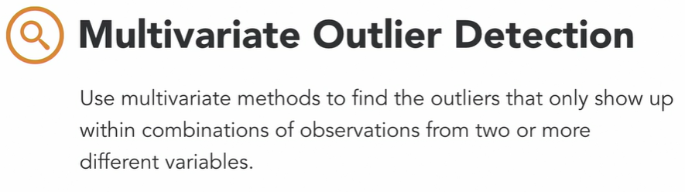

Let’s do it practically.

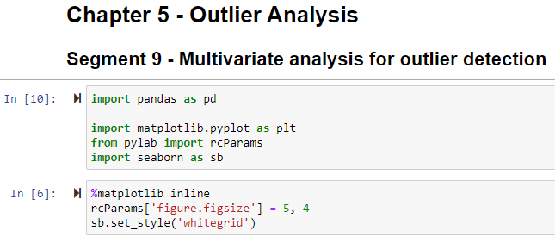

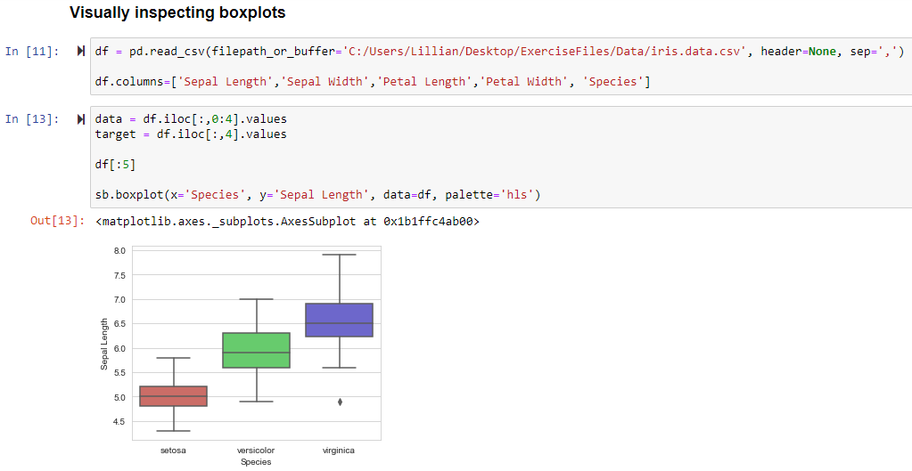

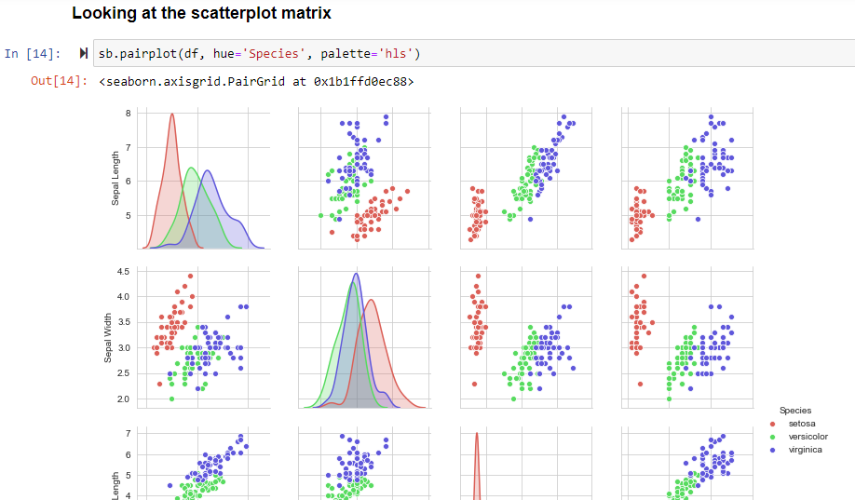

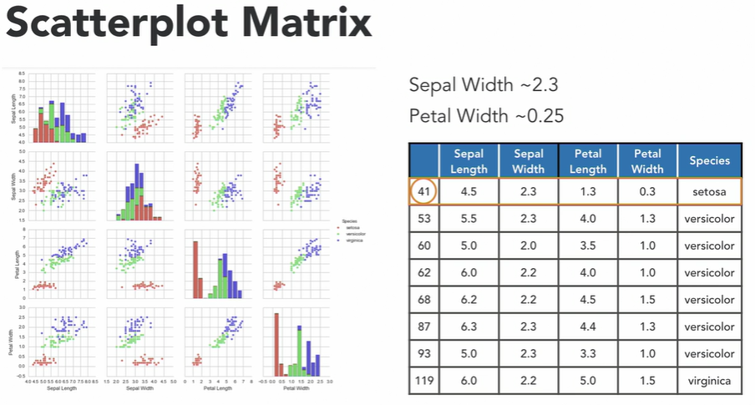

Quiz Questoins :-

Q) What is a boxplot?

* a display of a variable's spread

Correct

A boxplot is a data visualization of the minimum, maximum and interquartile range for variables and also outlier detection.

Q) Using the mtcars data set, what is the mean and standard deviation values for the qsec variable?

* Mean=17.85 and std=1.79

Correct

The mean and standard deviation for qsec.

Q) What does the describe function generate?

* descriptive statistics

Correct

The describe function generates the descriptive statistics for all of the variables in a dataset.

Q) What is the result of the multiplication of the 2x2 matrices a=np.array([[1.,3.],[2.,4.]]) and b=np.array([[5.,8.],[7.,9.]])?

* array([[5.,24.], [14.,36.]])'

Correct

This is the result of basic multiplication inputted by row values.

Q) What is the dot product of x=np.array([1,2,7]) and y=np.array([3,8,9])?

* 82

Correct

This computes (1*3)+(2*8)+(7*9).

Q) What is the matrix multiplication of the 2x2 matrices xx=np.array([[7.,9.],[5.,12.]]) and yy=np.array([[2.,8.],[7.,4.]])?

* array([[77.,92.], [94.,88.]])

Correct

This is the result of matrix multiplication with the matrix values being inputted by rows.

Q) What is the matrix multiplication of the 2x3 matrix xx=np.array([[1.,2.,3.],[4.,5.,6.]]) and the 3x2 matrix yy=np.array([[10.,11.],[20.,21.],[30.,31.]])?

* array([[140.,146.], 320.,335.]])'

Correct

This is the result of matrix multiplication with the matrix values being filled in by rows.

Q) What is a matrix?

* a two-dimensional container for elements that are stored in an array

Correct

This is the definition of a matrix.

There are 28 questions. So remaining questions u can copy – paste later at your rfee time.

Module – 6 :- DataSourcing via Web Scraping :-

Lecture - 1 :- BeautifulSoup Object :-



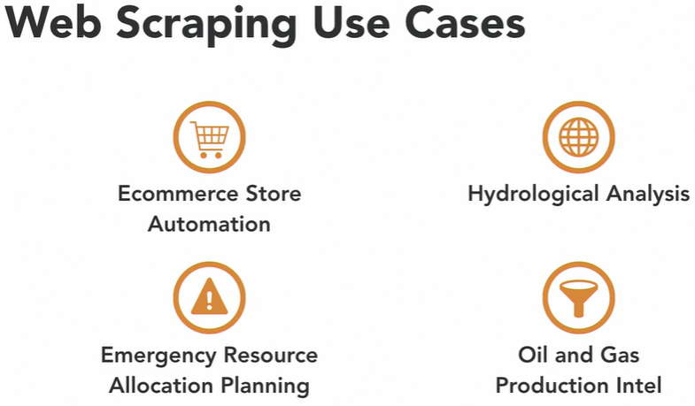

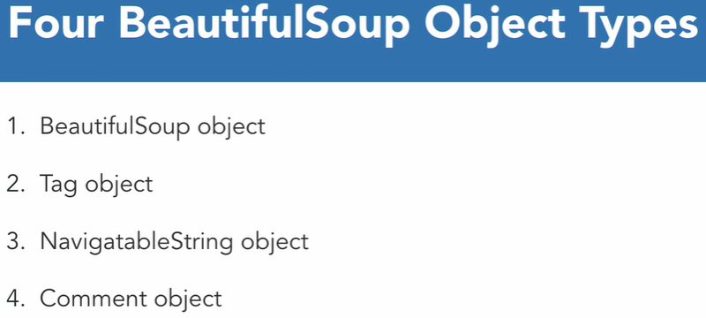

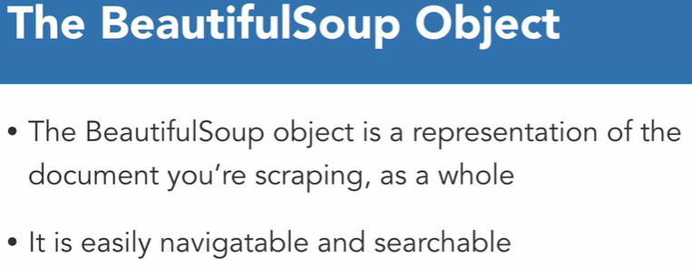

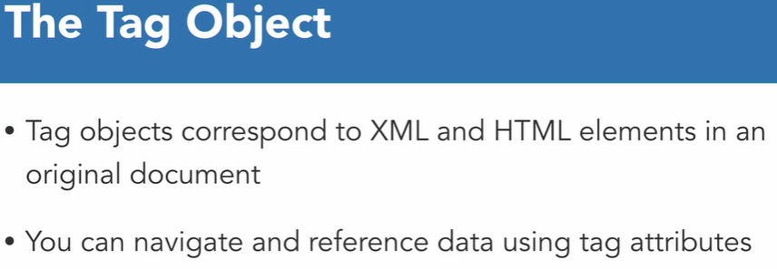

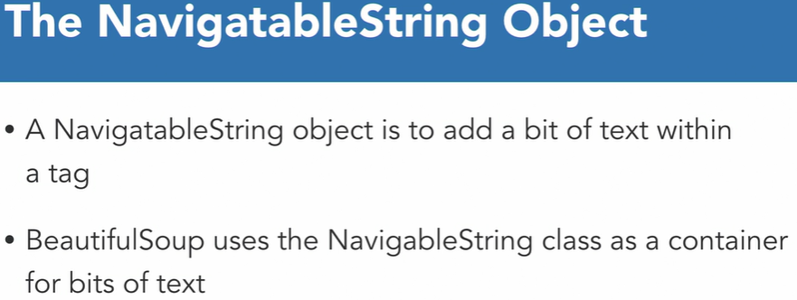

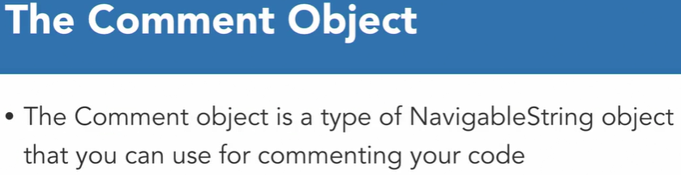

Let’s do it practically.

So first thing is to install beautifulSoup library using anaconda.

Open Anaconda prompt 🡪 run commands:- conda install -c anaconda beautifulsoup4

Now in jupyter notebook import sys module and import beautifulSoup as well.

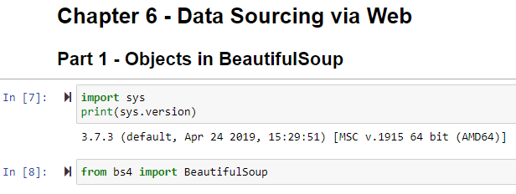

Now what we are doing is, instead scraping data from any other web page(which is also basicaly HTML page only), we will create HTML doc or page. And we will perform all things on it only.

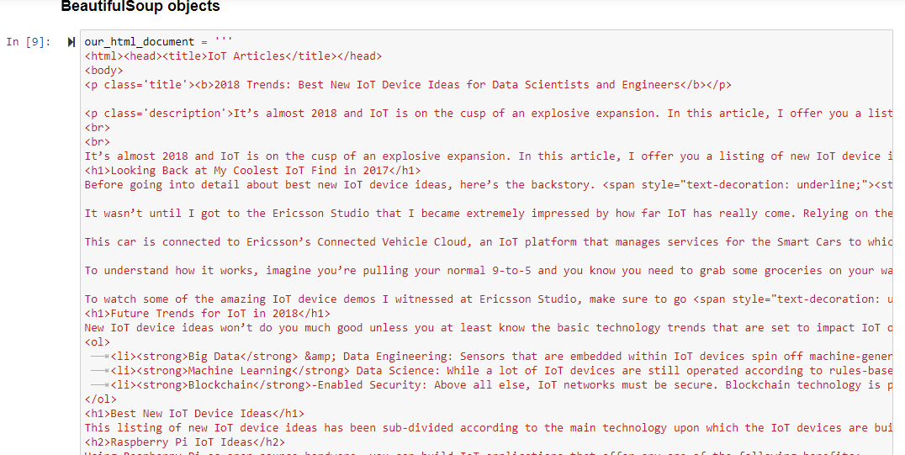

Now we will read the data using beautifulsoup object. So we need to pass 2 things while creating that object. 1st one is from where we need to read the data. And 2nd is which type of parser we want to use to parse the data. Actually we are having HTML doc or HTML language so we will use HTML parser.

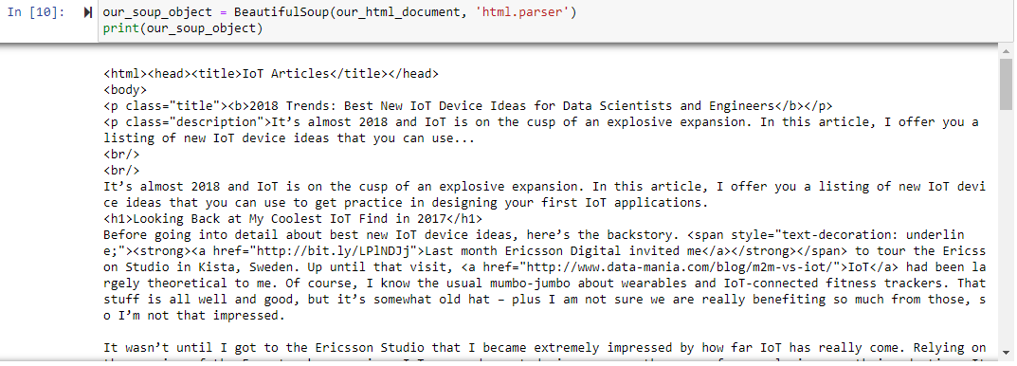

So now we can see that above scrapped data is much less readable as by default it is UTF-8 type. So we can use prettify( ) method to make it more readble. Here just to show we are only printing 300 characters.

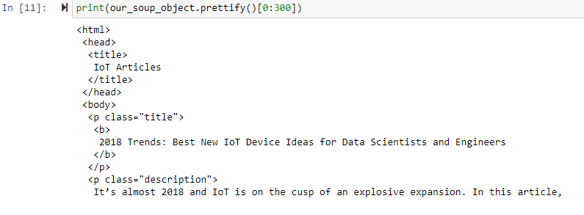

Lecture – 5 :- Introduction to NLP :-

As we know, almost al the text is in form of paragraph and it is sentenced in it. So sentence tokenization is the process to break the text into sentences.

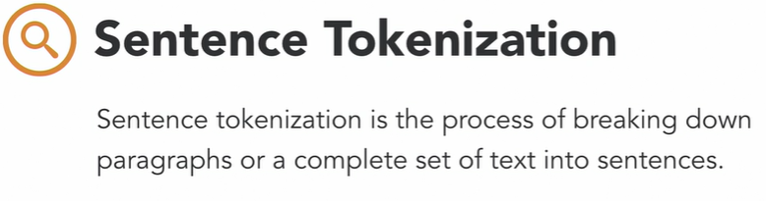

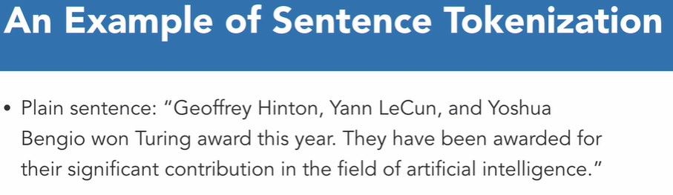

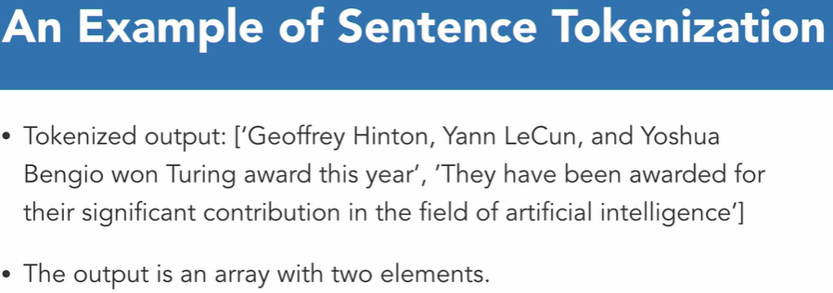

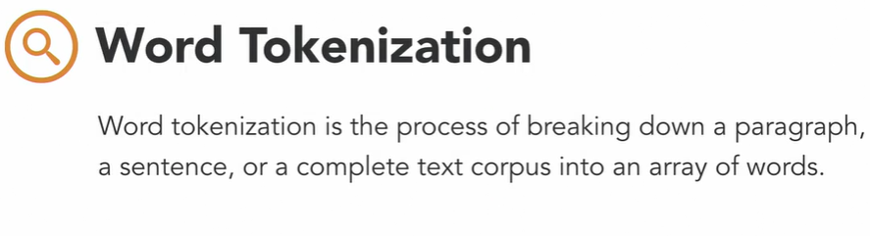

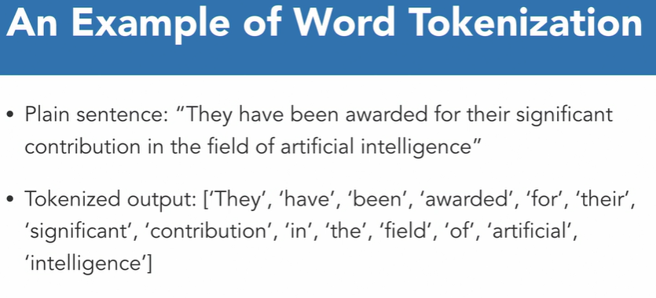



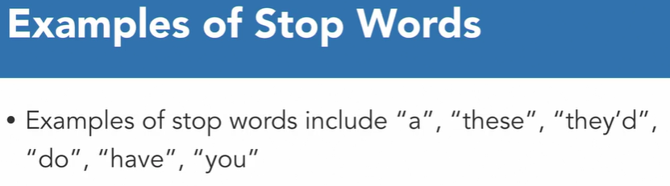

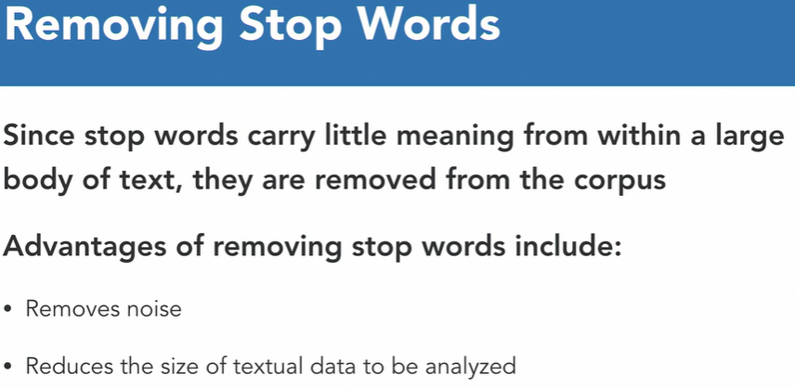

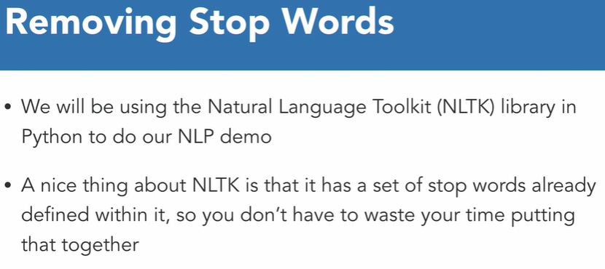

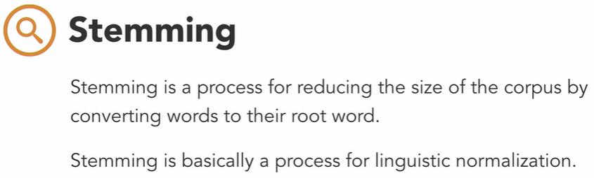



So while analyzing textual data, there is no meaning to get the 3 words representation to represent one thing.

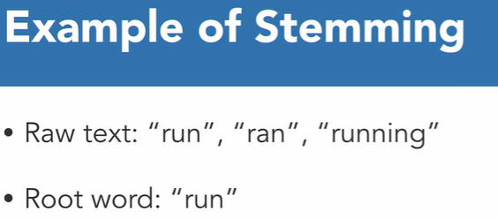

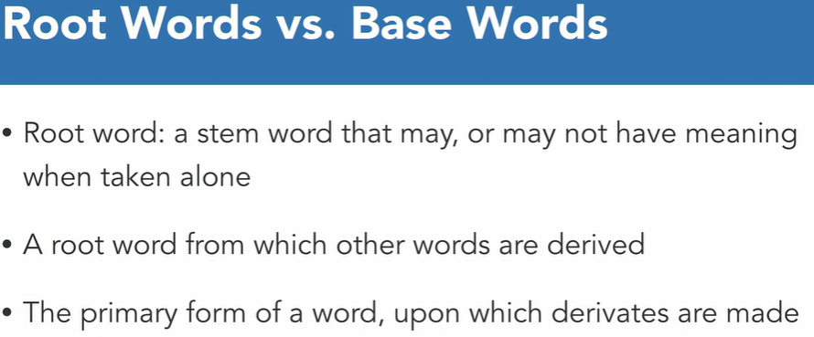

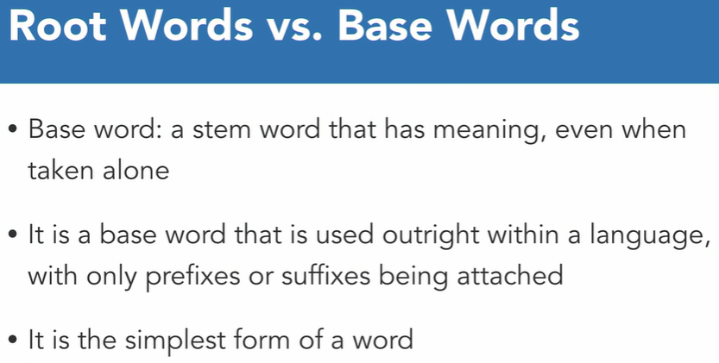

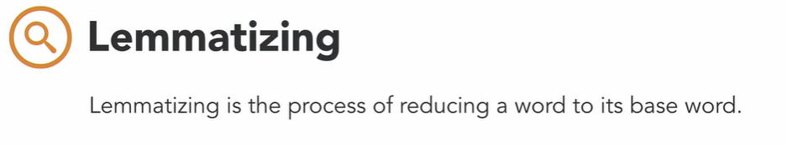

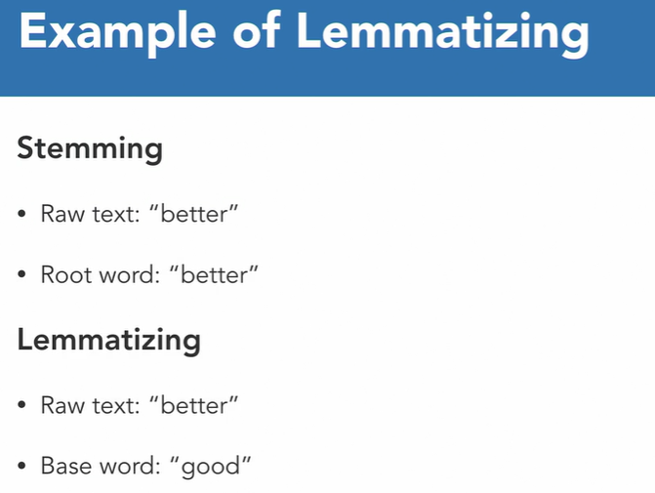



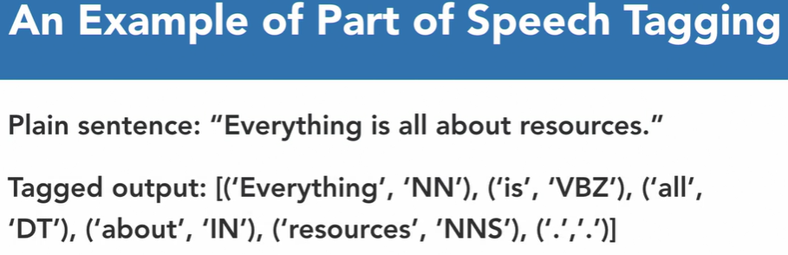

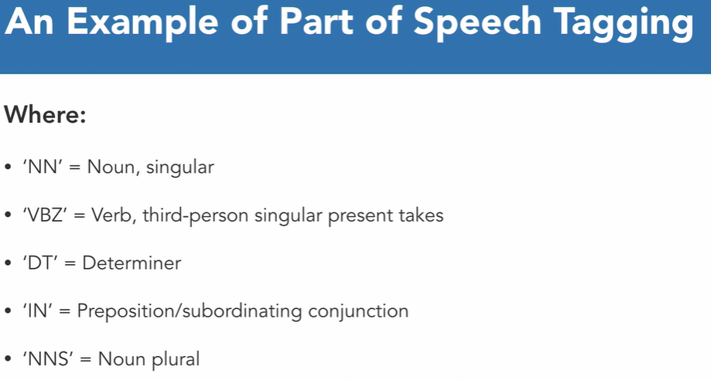

For reference :-

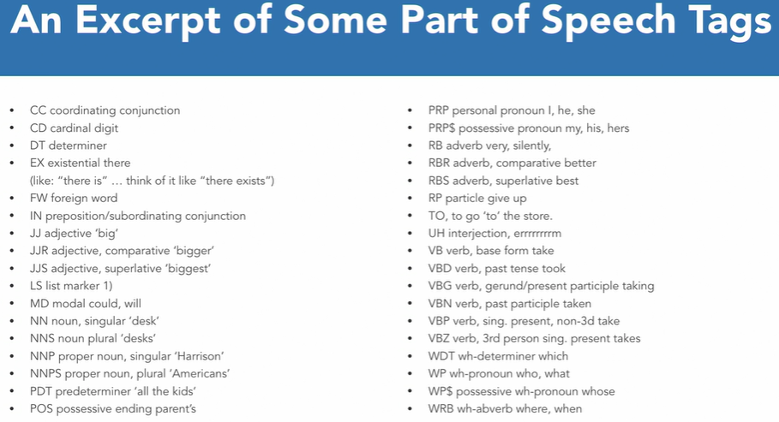

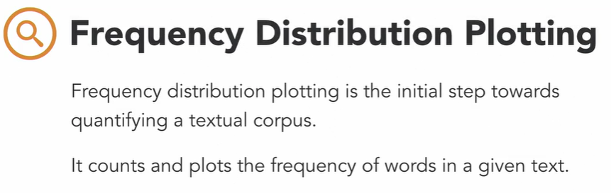

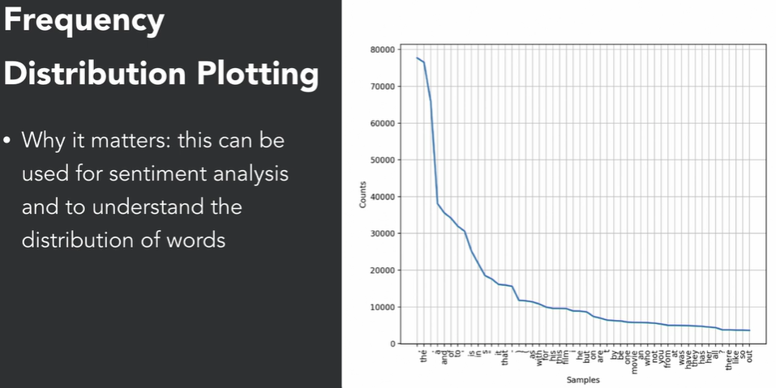

Now let’s do it practically.

First we need to install nltk in our env. So please run the below command in the anaconda prompt.

Conda install -c anaconda nltk

Quiz Questions :-

Module – 7 :- Collaborative Analytics with Plotly

Lecture – 1 :- Introduction to Plotly

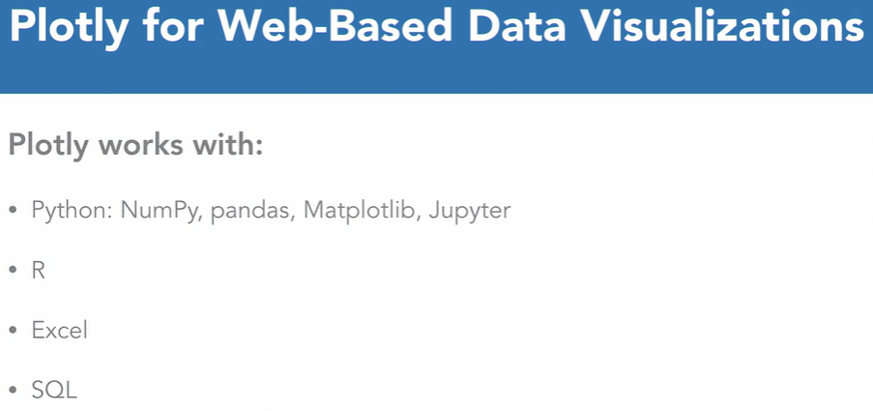

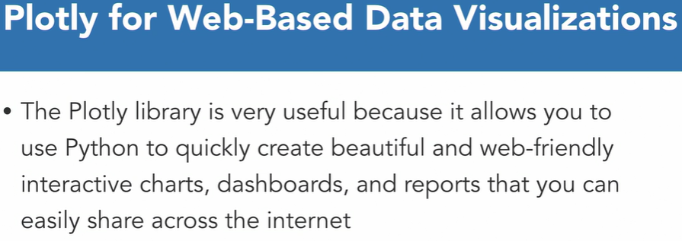

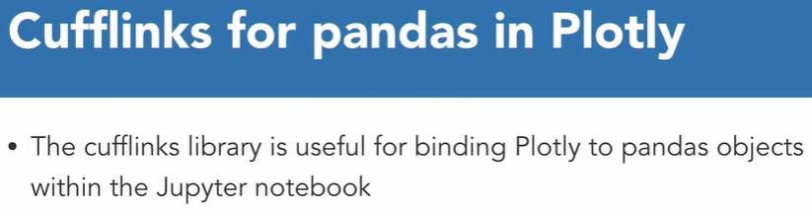

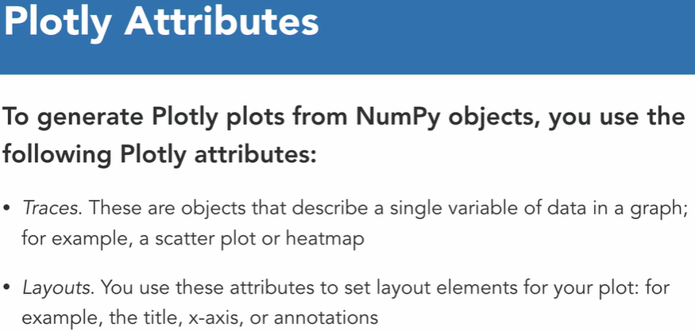

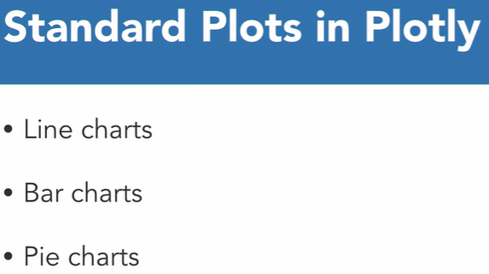

Lecture – 5 :- Create Statistical charts

